Kirkandrews on Eden WI 70th Anniversary

On 8th December 2020, during the Covid-19 pandemic restrictions, the Kirkandrews on Eden WI organised an Afternoon Tea Box for each of the Kirkandrews on Eden members which was to be enjoyed simultaneously at 3.30 pm but apart.

Glynis Milburn, Treasurer. awarded the 70-year certificates to two of the founding Kirkandrews on Eden WI members, sisters-in-law, Mrs Sadie Bell and Mrs Margaret Roe.

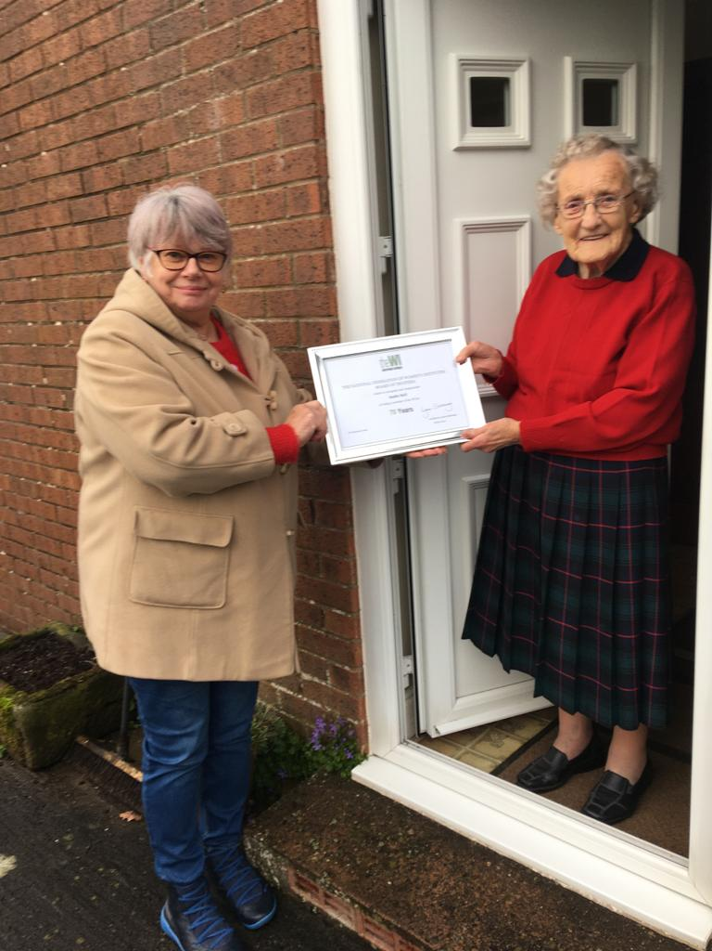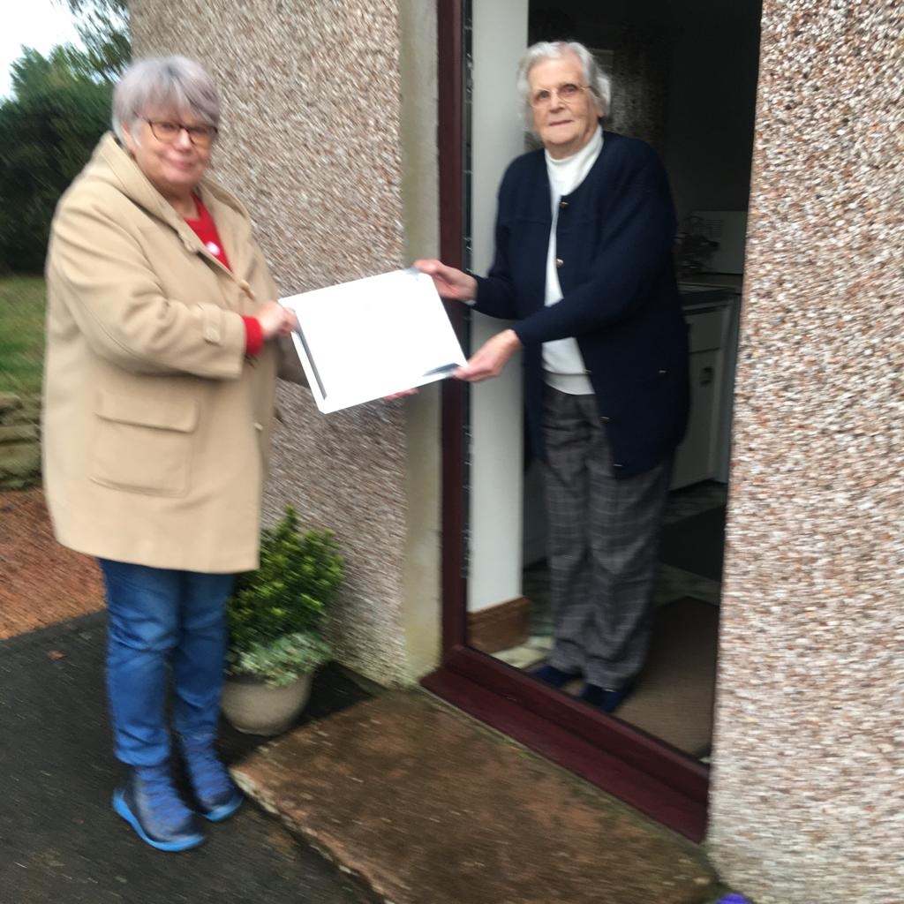
Sadie Bell Margaret Roe

