2019 Community Christmas Service at Beaumont Parish Hall

Members of the community were invited to a Community Christmas Service on Sunday 15th December to celebrate Christmas.

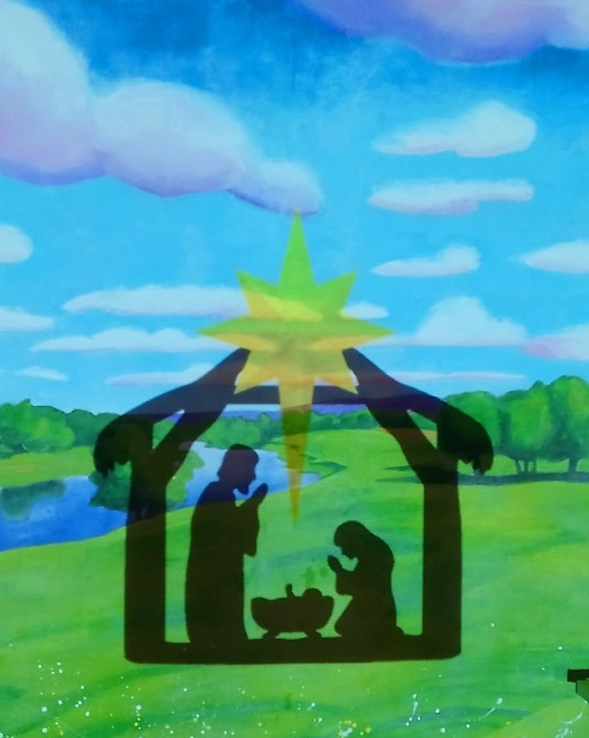

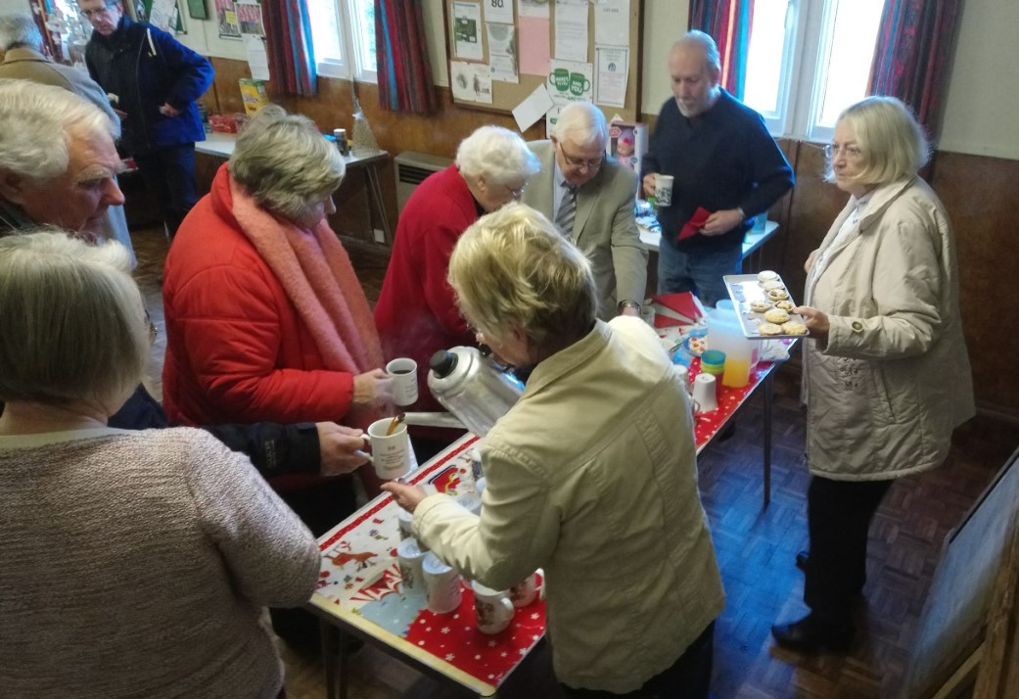

Coffee and mince pies were served before the service began.

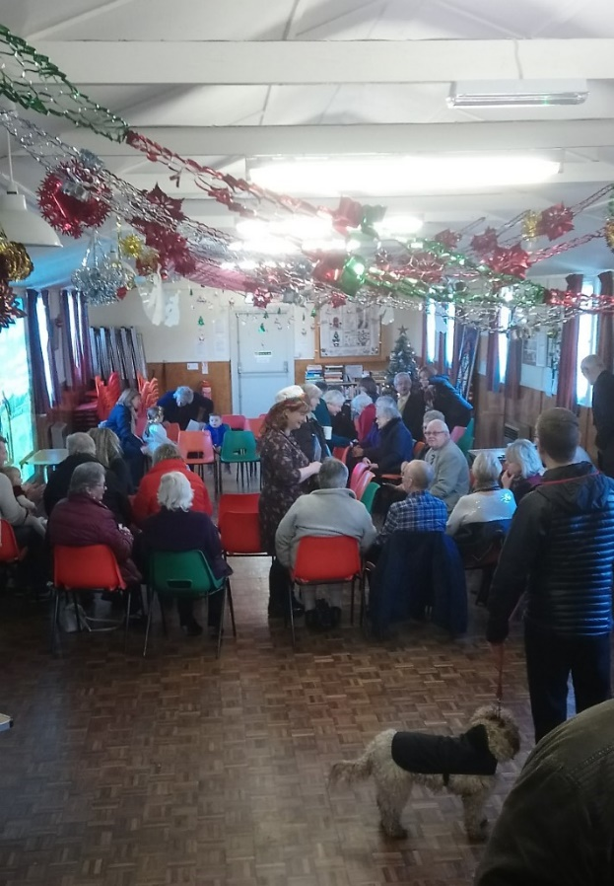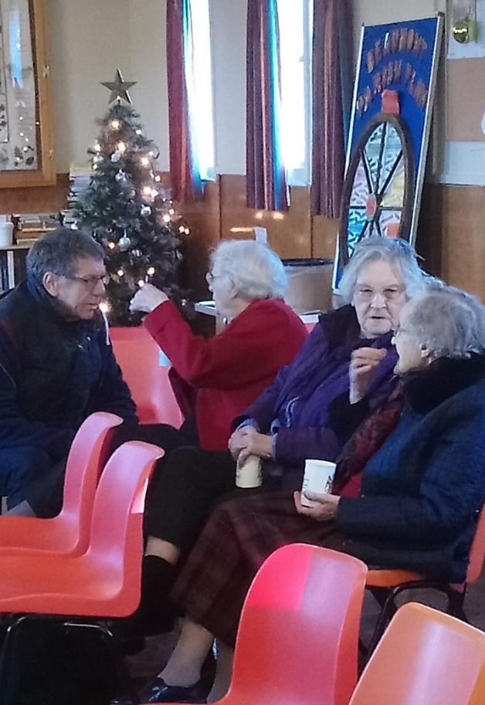

The Service
The service then followed at 10.30 am with contributions from several members of the community.
Rev. David Newlove welcomed everyone and said the opening prayers.

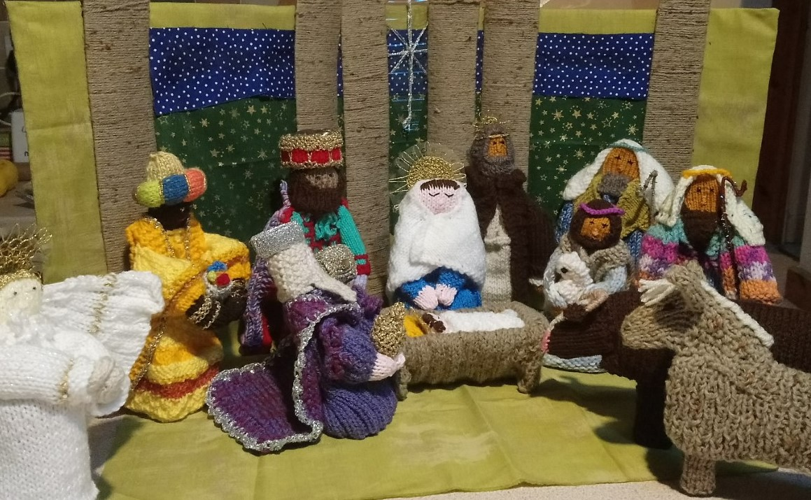
To represent the characters involved in the nativity story, figurines were placed in the stable next to the crib.

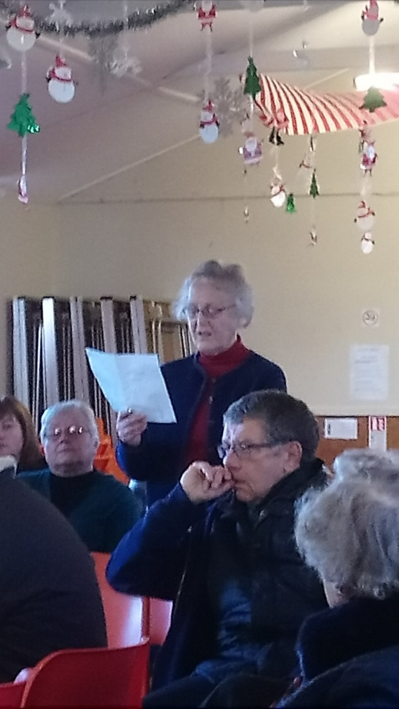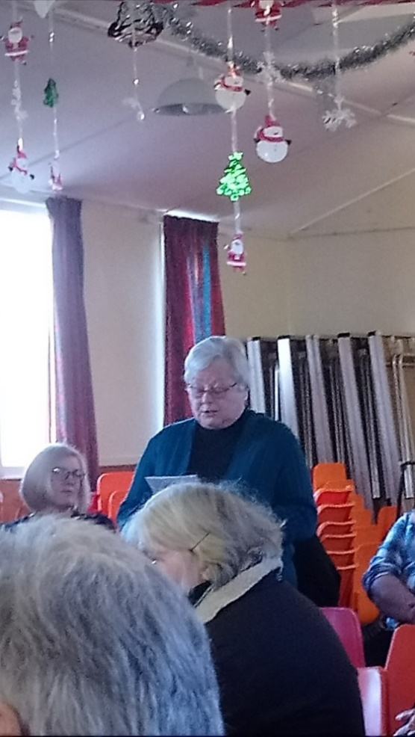
Margret Linda
Margaret read From Luke’s gospel, 1:16 38. Followed by Kate reading The Magnificat (Luke 46-55).
Linda the read an extract from Luke’s Gospel, 2: 8-14.
Reflections of the Shepherd’s was read by Glynis.
Linda then read again from Luke’s Gospel, 2: 15-20.
A reading from Matthew’s Gospel, 2: 1-12 was read by Kathleen
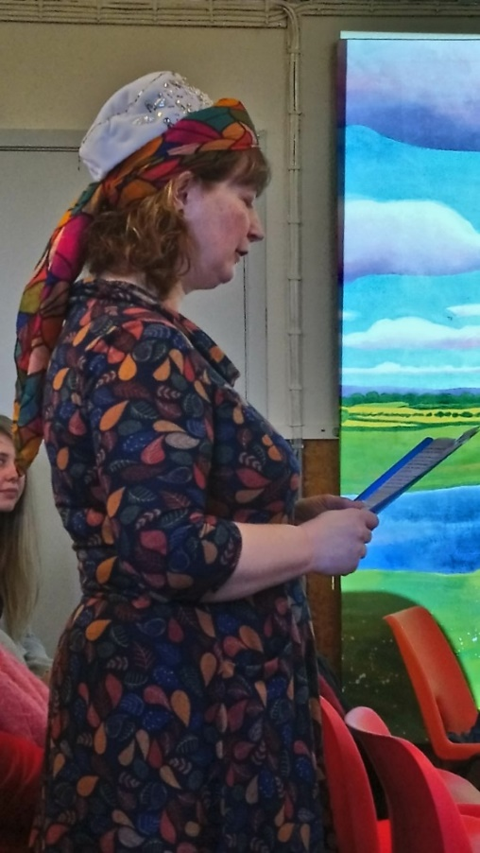
Bryony read some reflections of the Magi.

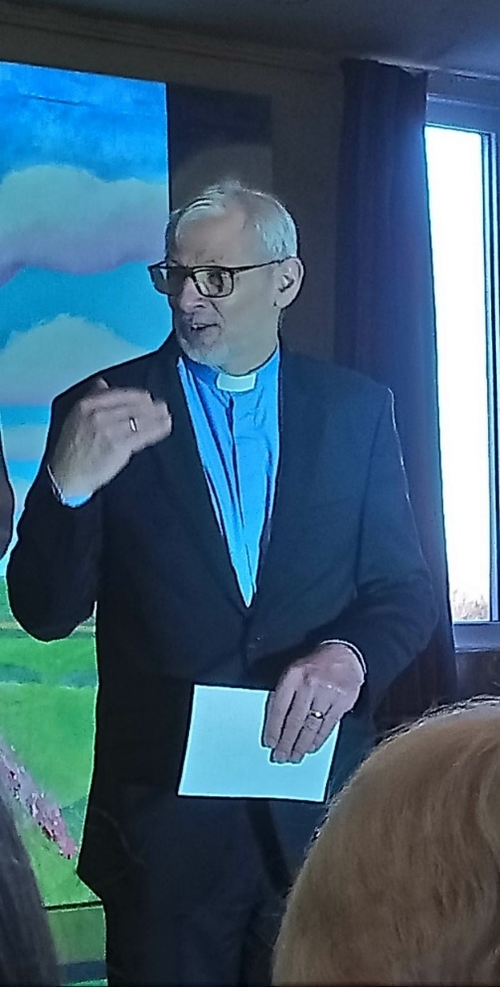

Rev. David Newlove then read the message.

This was followed by the Blessing.

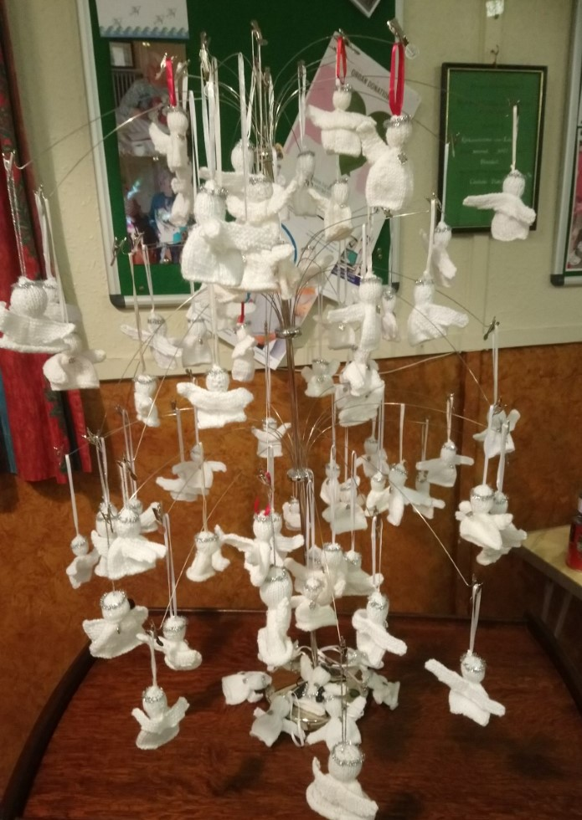

Those attending the service were given a Christmas present of a hand-made angel.

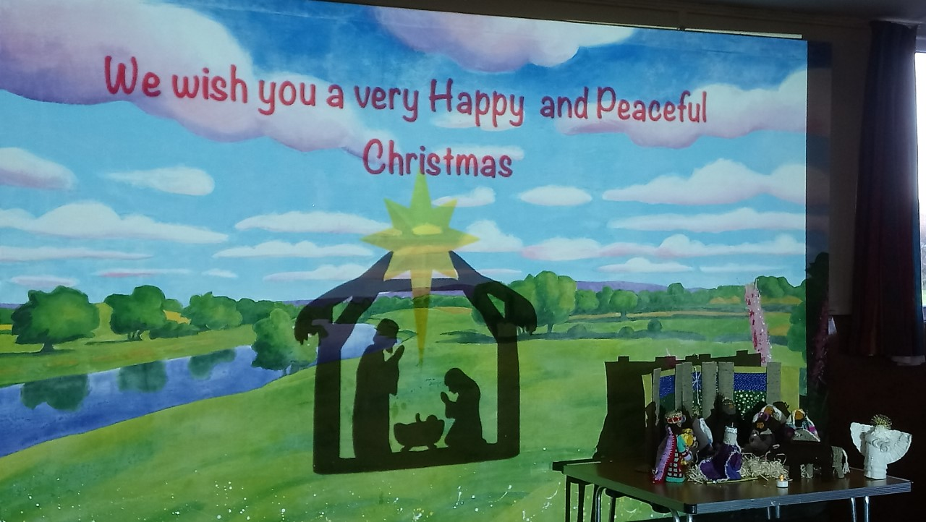
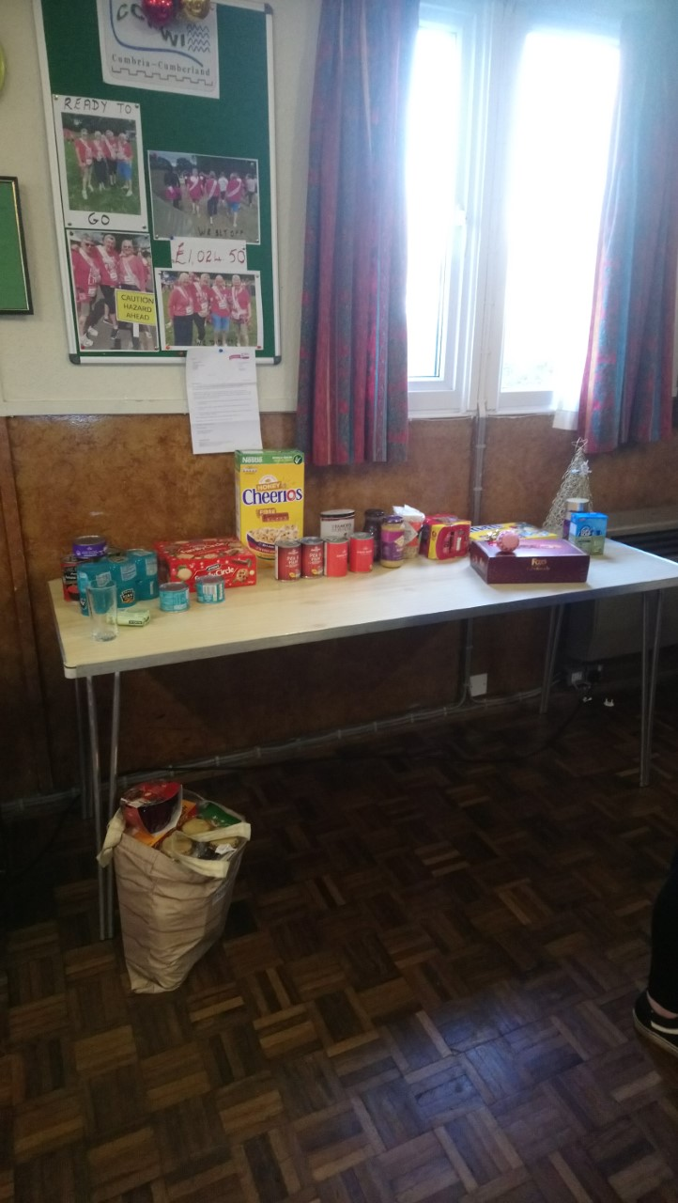

People were asked to bring with them a gift for the Carlisle Foodbank and/or a toy for a child in the Carlisle area to remember those less fortunate.

