St Mary’s is built on the line of Hadrian’s Wall. A turret would have stood on the site of the church.

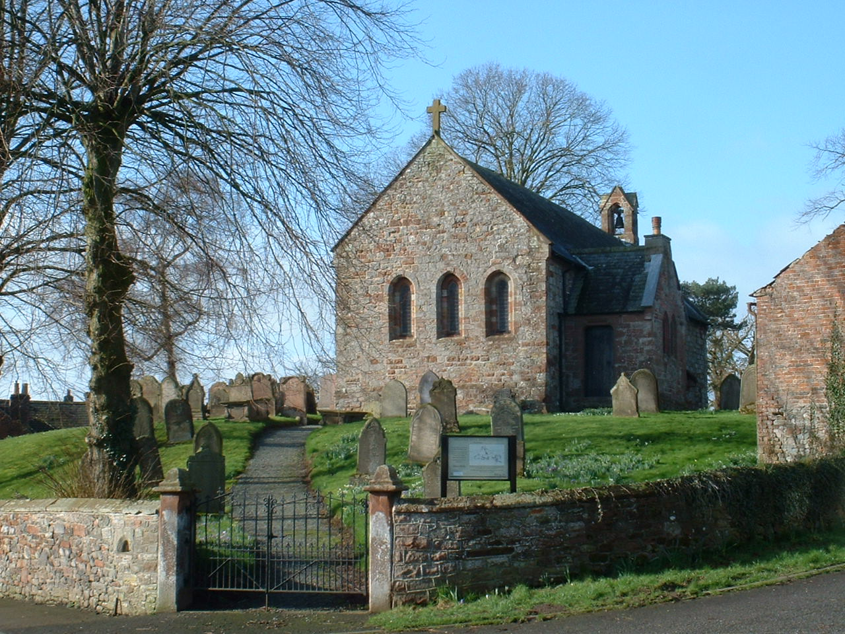
View of St Mary’s

When the Normans arrived they constructed a motte and bailey as a vantage point to repel invasion from the Scots. A castle of the Le Brun family, Lords of Beaumont, was set on the motte and eventually became St Mary’s Church. Stones from the Wall provided ready building material. A walk around the outside of the church will show evidence of stones from the wall as well original small window arches also used as building material for the vestry. To the south side there is a small trefoil-headed window possibly a lepers’ squint.

Wars and skirmishers continued in the area for centuries between English and Scots until the Act of Union of 1707 brought peace to the area.

The first Rector was Sir Elias de Thirwall appointed in 1296. A list of Rectors can be found on the west wall of the church.

Bishop Nicholson visited all the churches in his diocese in 1703 and found many in a sad state. At St Mary’s he reports that, “The Church is in good repair as could be expected; but has not a letter on the walls, floor or churchyard. The East window in the Quire needs glass.......... The Rector has neither House nor Gleab.” (sic.) The Rector, Mr Gabriel Trant, must have had a hard time.

Restorations in 1872 and 1888 left the interior of the church in its present state. A kneeler placed in the desk by the choir stalls gives details of the work carried out.

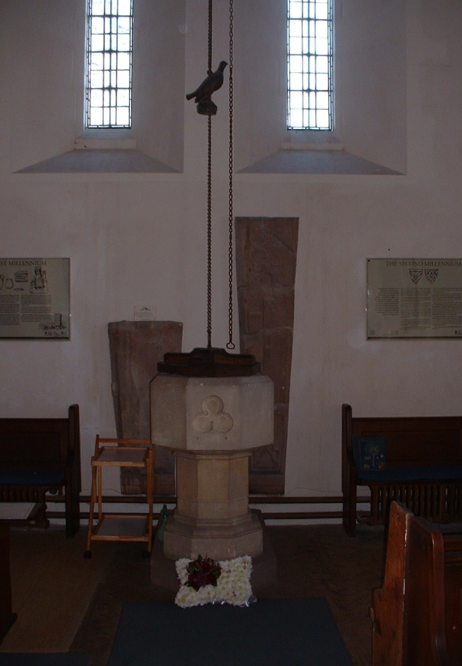

More recently pews have been removed at the back of the church to give extra space for Baptisms and social occasions. This is also a corner for children to play during services.

Photograph of the font to the rear of the church

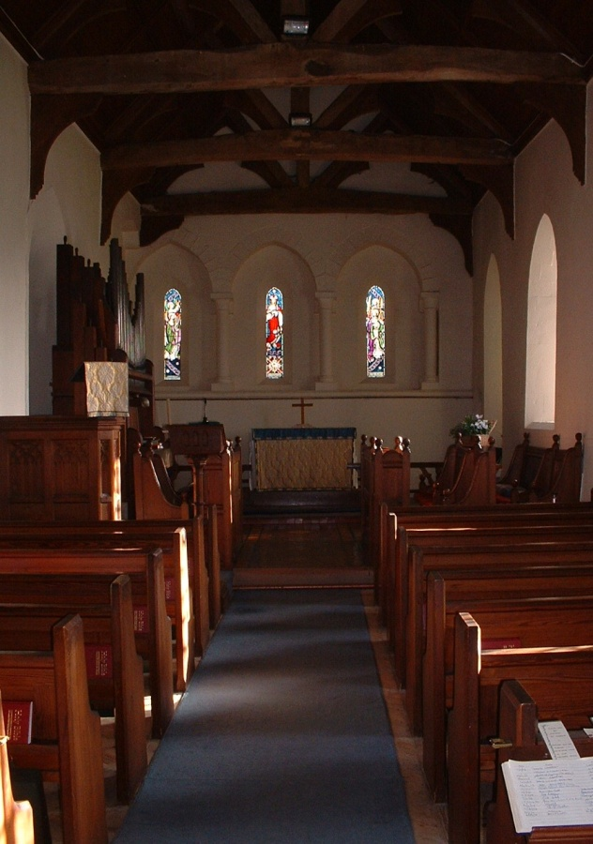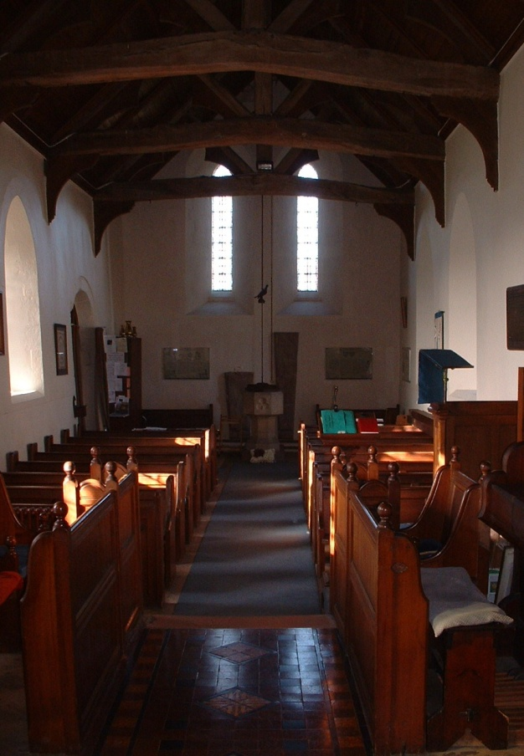
Photographs of the interior of St Mary’s

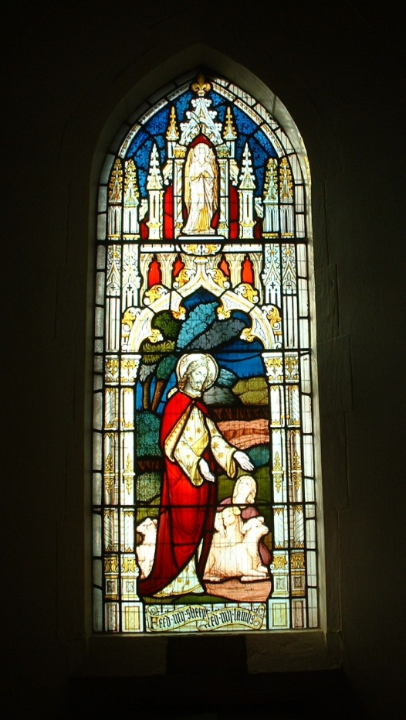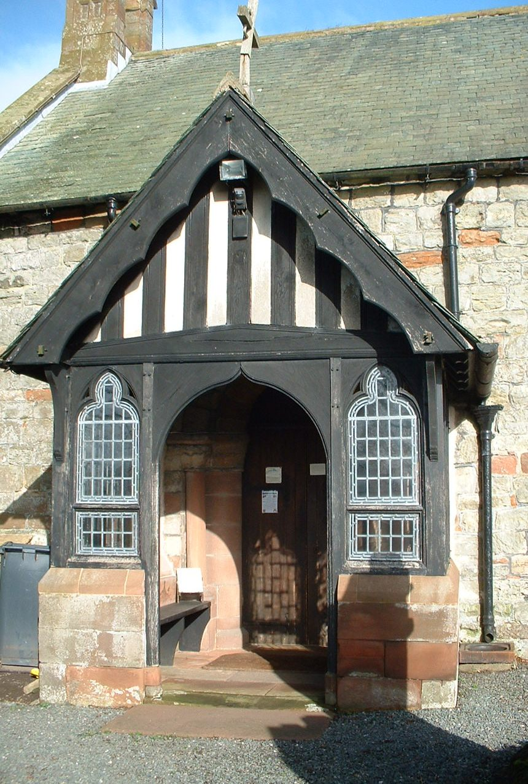

Porch in 2014 Porch in 2014

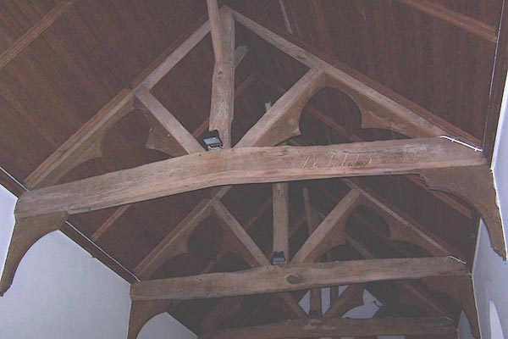

Exposed roof beams

In 1996 we celebrated 700 years. Kneelers were made to commemorate Rectors from each of the centuries. These were stitched by members of the church and can be found on the front two pews. You can see more information about the kneelers on a separate page of the website.
In the church a board setting out more details can be found at the back of the church.
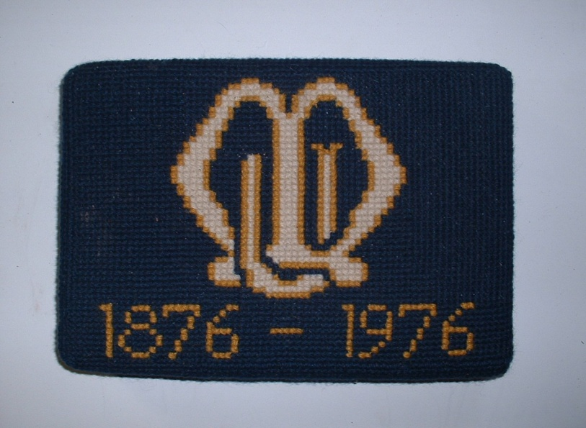

Photograph of one of the kneelers

Set into the west wall are two medieval grave slabs found in the churchyard in 1872. They are to the memory of a harpist and a deacon.

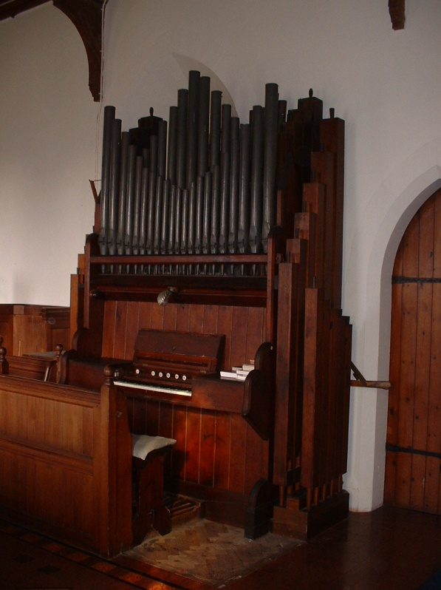
The organ is a single keyboard with pedals. It was powered by bellows which had to be pumped by hand (see photo for hand lever to the right of the organ)). In 1970 an electric blower was installed but the hand pump remains and has proved useful at least one occasion when the power failed.

In 1978 a “village museum” open day at the then vacant Rectory was organised, showing what the Rectory may have looked at in 1845 when it was built, to raise money for the restoration of the organ.

A set of Nativity figures made in 1980 by Celia Batey was designed to fit across the ledge of the east window. She also made the figure of the Virgin and Child which can be seen to the left of the east window.

Photograph of the organ at St Mary’s

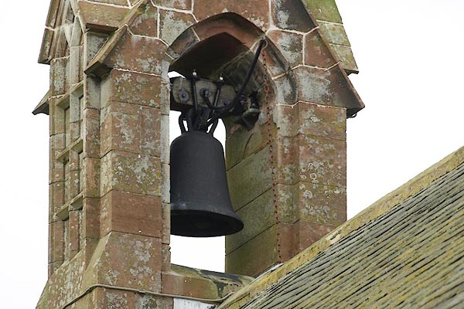
The terrier of 1749 and subsequent terriers mention a single bell. There is still only one bell of size “22 inches in diameter, weight about 2 ½ cwt. The Rev. R S Green, vicar of Cross Canonby and Mr W C Parker who have examined the bell describe it of having its crown shaped like a policeman’s helmet, and a metal loop, as if for suspension, surmounting its canons; no date or inscription of any kind. The shape of its crown suggests it was set in Carlisle in the 1820’s.” (Extract from Whitehed 1885, Vol 8 p 509)

Photograph of the bell of St Mary’s.

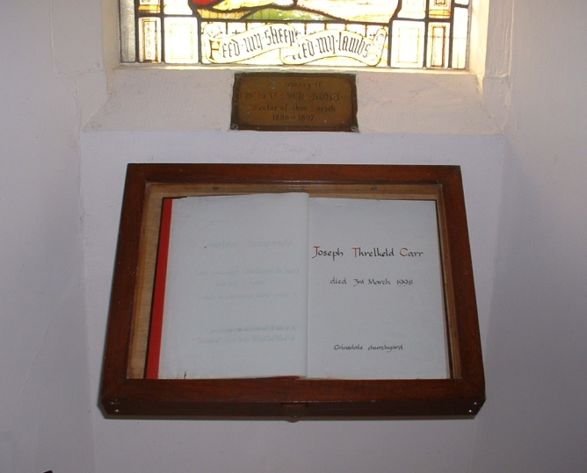
The First World War Memorial is on the north wall. The names were researched a few years ago and the resulting book is on the stand in the chancel window. The Second World War Memorial was probably made at the Keswick Schools of Arts and Crafts.

Photograph of the World War book.

Should you need any further information ring Margaret Parkinson on 576339.

Because we are on Hadrian’s Wall Path many people from far afield visit our small church. Some of those who write in our Visitor’s book
have found peace here.

Other information relating to St Mary’s

St Mary’s is a Grade II* listed building. The following are the listed building descriptions for both the church and the churchyard wall South of St Mary which is Grade II listed.

Church.
Late C12 with restorations of 1784, 1872 and 1888. Squared and coursed red and calciferous sandstone (from the nearby Roman Wall) on chamfered plinth. Graduated green slate roof with coped gables and cross finial. Nave/chancel of 5 bays with west open bellcote, south porch and north vestry. Timbered C19 porch; entrance with reused Norman arch of 2 orders, engaged columns with waterleaf capitals. Pointed lancet windows of 1888, small original trefoil-head window is suggested lepers' squint. C12 3-light east window; 2-light west window is C19. Interior has C15 king-post open timber roof. Piscina dated MDCCCLXXII and possible aumbry recess. East end has late C12 arcade continued on north wall but stops short of south wall; C19 stained glass. West wall: 2 medieval grave slabs. Late C19 furnishings and fittings. Built on the site of a turret on the Roman Wall.

Churchyard Wall south of St Mary.
Dated 1897 on gates. Mixed red sandstone rubble and cobbles, chamfered red sandstone coping. Wall enclosing south and east sides of churchyard. 2 entrances, squared gate posts with shaped caps; wrought-iron overthrows with converted gas lamps, lamp missing from east entrance. Recess to left of east entrance is round-headed arch from original church window.

Many have tried to capture St. Mary’s. The image below is one drawn by the Rev. Ford c.1850.

