A list of the clergy of Beaumont, Kirkandrews on Eden and Grinsdale

Rectors of St Mary’s Beaumont, Beaumont

Sir Elias de Thirwall appointed 1296
Adam appointed ?
Walter de Arthuret appointed 1336
William Browne died 1339
Richard Browne appointed 1339
Thomas de Sourby appointed 1365
(Bequeathed 20s to fine lights in church)
Adam de Caldbeck died 1366
Walter de Ormsheved appointed 1366
Robert Croft appointed 1380

Robert Chapman rector in 1490
Thomas Thompson deprived 1560
Whellan (p148) “In reign of Elizabeth for refusing the oath of supremacy)
Henry Haselhead appointed 1562
Sir Launcelot Wilson appointed 1581
Edward Johnston resigned 1611
Thomas Thomson appointed 1611
Sir John Wilson appointed 1615
Thomas Robinson appointed 1616
Thomas Warwick appointed 1625
Andrew Smith appointed 1634
Patricus Hume appointed 1663

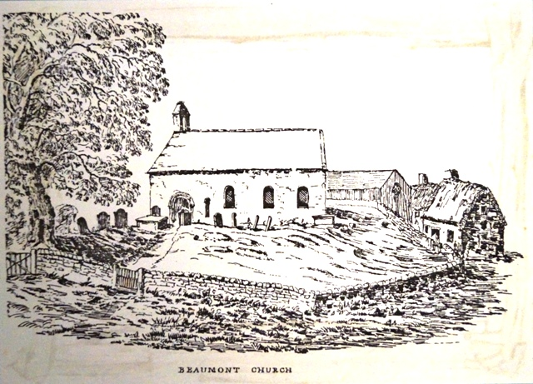

St. Mary’s Church, Beaumont

Rectors of St Andrews, Kirkandrews-on-Eden

Sir John Palmer resigned 1361
N & B (11.226)”Had a certificate from the bishop of his voluntary resignation and fair demeanour in the diocese of Carlisle”
Sir John de Bempton appointed 1361
N & B (11.226) “Had a dispensation for one year’s absence”
Thomas Watson died 1576
Christopher Lowther appointed 1576
William Witton appointed 1587
George Millikin appointed 1611

Vicars of St Kentigern, Grinsdale

John Stamper appointed 1738
William Baty appointed 1761
Thomas Pattinson appointed 1777
Jonathan Wilson appointed 1829
Henry Gough appointed 1848
John Barton Norman appointed 1855
Frances John Allnatt appointed 1869
Matthewman Sidney Donald appointed 1895
Joseph Chapelhow appointed 1899

Rectors of Kirkandrews-on-Eden with Beaumont

Richard Wilson died 1692
Acquired 80acres at Preist Hill by enclosure. It passed to Rev. G Hume, whose wife kept it.
George Hume appointed 1692
Gabriel Trant appointed 1703
N & B (11.225) “In 1703 Gabriel Trant was instituted both to this Rectory and that of Kirkandrews on Eden, vacant by the death of George Hume, on the presentation of Richard Viscount Lonsdale”
Thomas Lewthwaite appointed 1705
George Bowness appointed 1762
N & B (11.224) “Built a rectory from ruins of old church”
Richard Burn, Snr appointed 1780
Richard Burn, Jnr. appointed 1815
William Benn, B.A. appointed 1846
John Brown, B.A. appointed 1852
(See ballad written by Rev. George Mercer Tandy)
Thomas Owen Sturkey, M.A. appointed 1886
Joseph Chapelhow, D.D. appointed 1897

Rectors of Kirkandrews-on-Eden with Beaumont and Vicars of Grinsdale

Joseph Chapelhow D.D. appointed 1908
“A portly cleric who had a carriage from Carlisle to take him to Beaumont”
John Alfred Kitchin appointed 1914
“He seldom went out except to church”
Reginald Samuel Edward Oliver, B.A. appointed 1926
John Lloyd Crawley, M.A. appointed 1948
William Hartley appointed 1952
“A former merchant seaman who breed Pekinese”
Henry Whiteley, M.A. appointed 1954
Deryck Barnard Garland, M.A. appointed 1965

Priests in charge of Kirkandrews-on-Eden with Beaumont and Grinsdale

David Osborne appointed 1972
A member of the diocesan Education Staff
Geoffrey Dobson appointed 1978

Vicars of the United Benefice of Burgh by Sands with Kirkbampton and Kirkandrews-on-Eden with Beaumont and Grinsdale

Christopher Stone appointed 1984

Rectors of the United Benefice of the Barony of Burgh

Davis Russell King, B.A. appointed 1990
Gillian Mary Heart, B.Sc. appointed 2003
Tudor Boddam-Whetham appointed 2011

