Presentation to Alan Hodgson

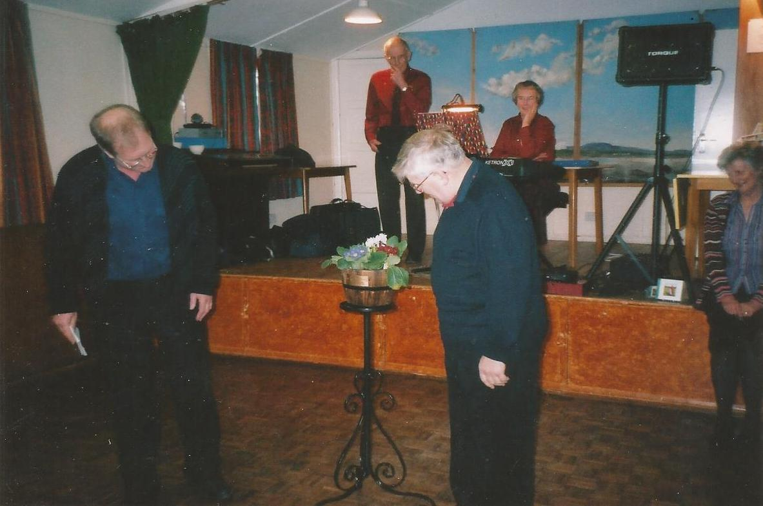
Presentation to Alan Hodgson recognising his time as Chair of the Parish Hall

