**Beaumont Parish Hall Bonfire Night**

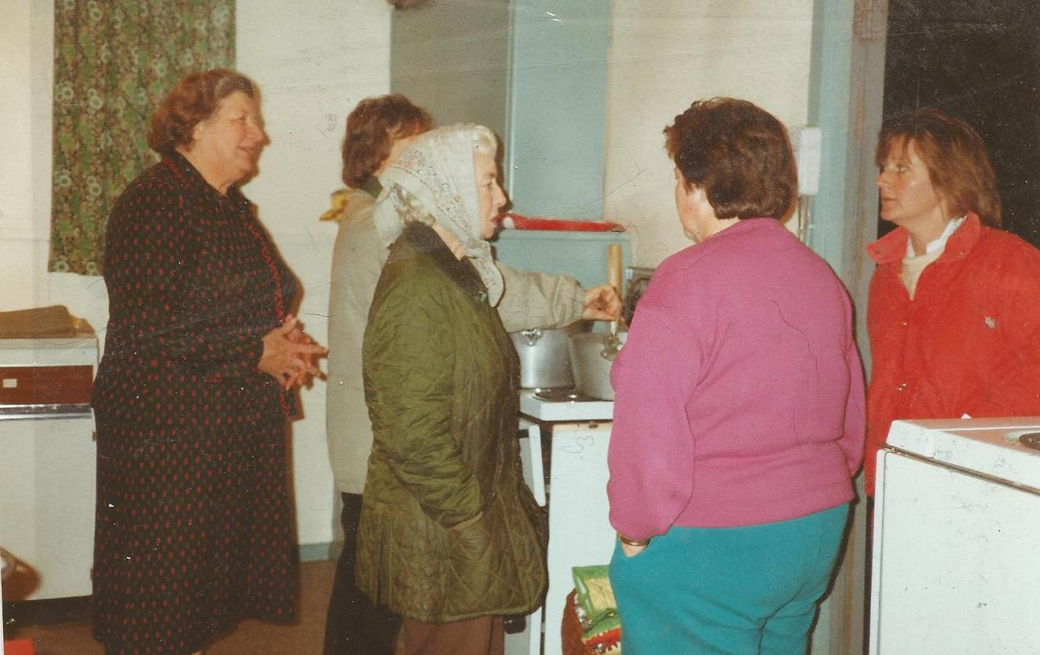

*Preparations in the kitchen*

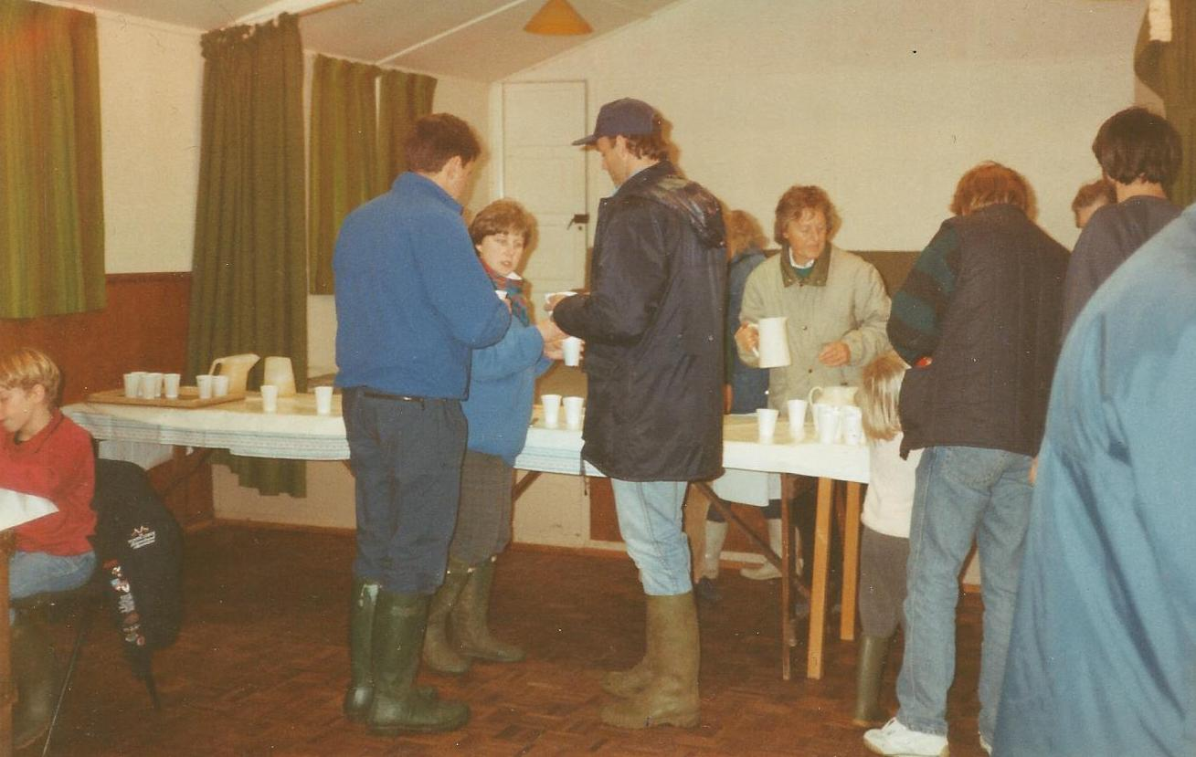

*Supper time*

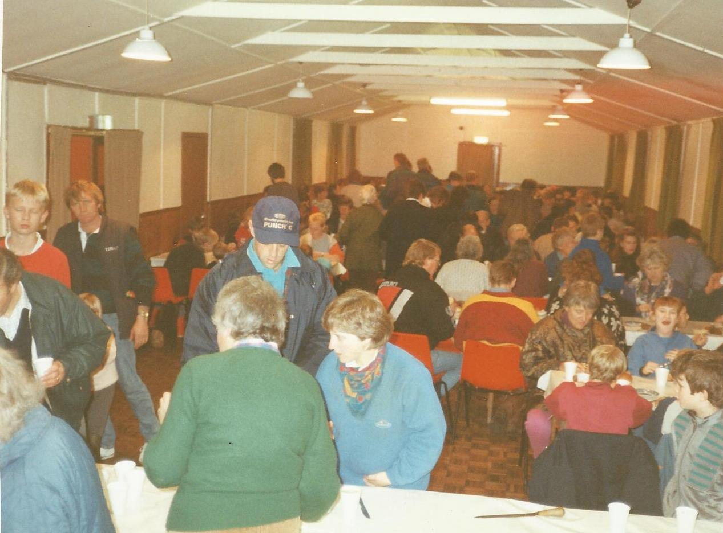

*Supper time*

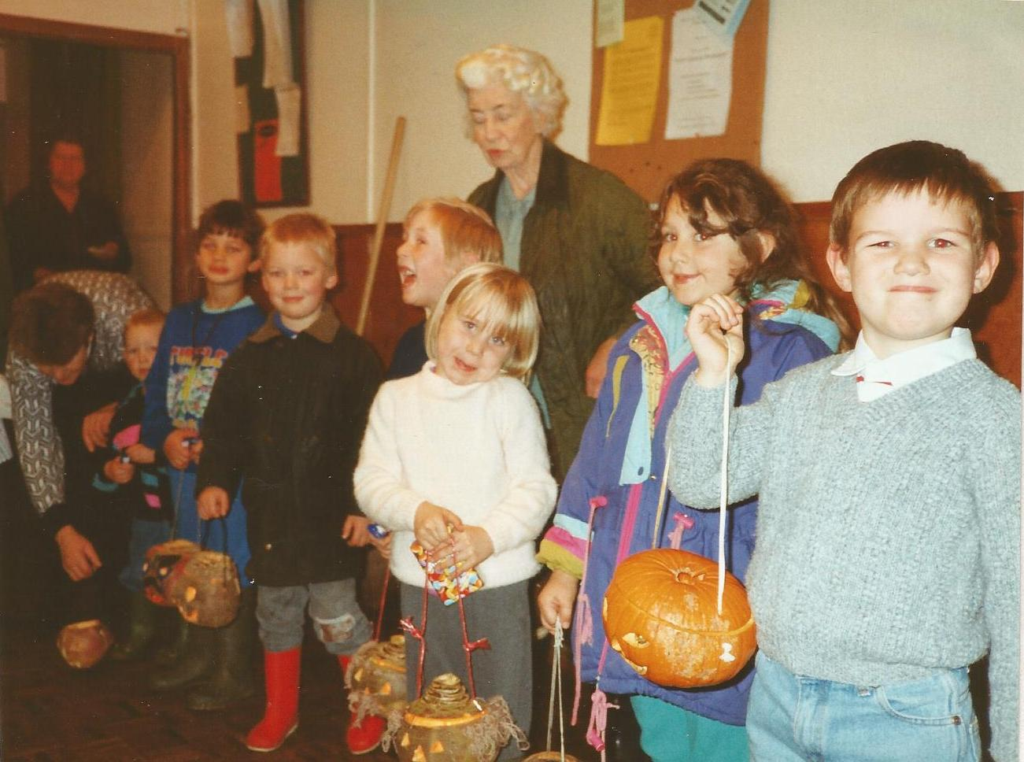

*Miss Margaret Vickers judges the turnip lanterns*