Beaumont Parish Drama Group presented “Chinese Pendant” in 2007

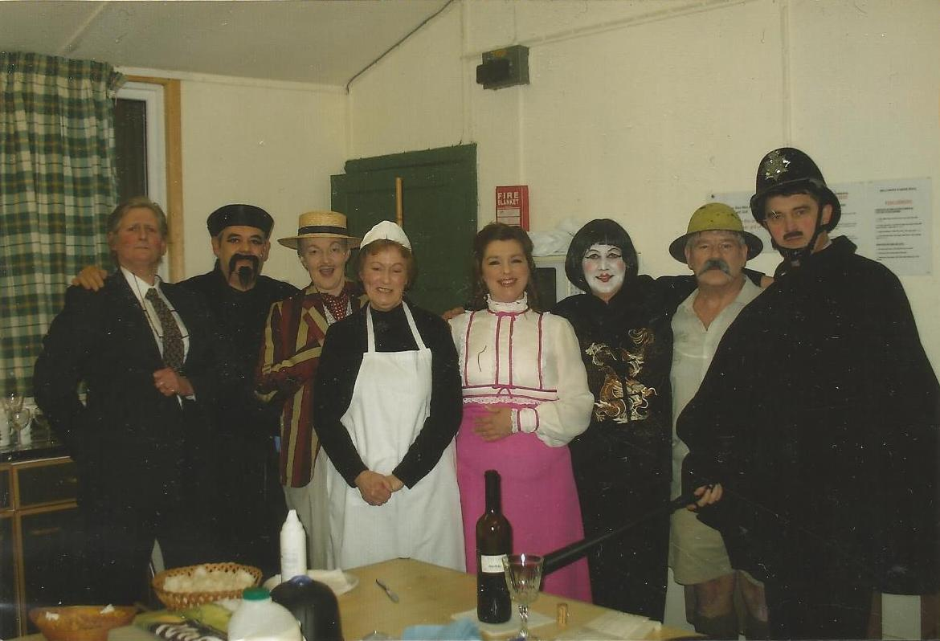
Cast: Margaret Harrington, Bernie Frazer, Rosalind Bell, Marion Cook, Aileen Johnston, Corrine Riley, Alan Hodgson, David Ewing

