A history of St. Kentigern’s Church, Grinsdale

Tradition ascribes the evangelism of the district to St. Kentigern, popularly known as St. Mungo, in the later part of the 6th century. It is interesting that in England, the only ancient churches dedicated in his name, eight in number, are all here in North Cumbria.
St. Kentigern, while Bishop of Glasgow, was driven from his home by a new and hostile King of Strathclyde and he decided to seek refuge amongst the Christian Britons of Wales. Jocelyn, a monk in Furness, in his life of the saint, which he wrote about in 1185, says that he interrupted huis journey to preach in the district around Carlisle, having heard that the people of the fells and dales had relapsed into heathenism.

The church was rectorial, and dedicated to St. Munge, or as some name this personage Kentigern. It was part of the possessions of Lanercost Priory, being given thereto by Hugh de Morville, Lord of Burgh, and was soon after appropriated, the cure being served by a brother of that house, without any vicarial endowment. The rectory and advewson of Grinsdale passed to Sir Thomas Dacre, with the other possessions of the dissolved monastery, by the grant of King Edward VI. His descendants have constantly appointed a curate with the salary of 40/-d. yearly, to maintain their ecclesiastical right, though the church lay in ruins for many years. It was not till about the year l743 that it was rebuilt by Joseph Dacre Esq. at his own cost.
"The church stands pleasantly upon the banks of the Eden, and, being white makes a very pretty appearance."
Some of the historian's facts are a little inaccurate as we shall see later) and the church is no longer white although its appearance is still very pretty, especially when the daffodils are in bloom in Spring. However Hutchinson does give us, some insight into the life of the village at the turn of the eighteenth century. The extent of the parish from north to south was one mile, and from east to west one and a half miles.

From the village let us turn our attention to the church which stands two fields away on the banks of the Eden. St. Kentigern, to whom the parish church is dedicated, lived at the end of the 6th century. He was Bishop of Glasgow; and when he was driven out of Scotland by the marauding Angles, he retired to Cumberland, and built various churches in this part of the world, including no doubt a church on the site of the present church at Grinsdale. Kentigern seems to have established churches by Holy Wells, the exceptions being Grinsdale and Crosthwaite. Kentigern would have probably baptised people in the Eden. Population was sparse in Cumberland and well away from the main areas of population in the south. This did not help with the spread of the Gospel or the fame of Kentigern. Had he arrived in Kent instead of Augustine then his missionary zeal would have produced the same effects and his name would be known throughout the land. As it is we know little about him and few outside the county have heard of him.

The original church, of St. Kentigern was probably older than the 12th Century. Originally it had been part of the parish of Kirksteads which 'covered the area which is comprised of Grinsdale, Kirkandrews-on-Eden, Beaumont and Great Orton. At some stage the parish split and the church and religious house at Kirksteads disappeared leaving four churches in new parishes. In the reign of Henry 11, Hugh de Morville, Lord of the Barony of Burgh, granted the church at Grinsdale to the Canons of Lanercost Priory. From this time until the Dissolution of the monasteries in the mid-sixteenth century it was served by a monk from Lanercost who would probably row across the river to say Mass. After the suppression of the monastic houses the right of appointing a minister was given by Edward VI to Sir Thomas Dacre.

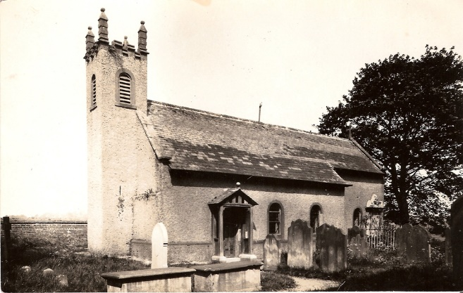
Taken in 1928

No services seem to have been held in the church from after the Reformation until 1741 a period of about two hundred years; and the building fell into ruin. The church at Grinsdale's sister parish, Kirkandrews-on-Eden, also seems to have fallen into disuse at about this time.

In 1703 Bishop Nicholson visited the parish and wrote, "The church and chancel were both in ruins; nothing left but a good handsome stone table heretofore used as an altar. Half of the churchyard seems also to have been carried out by ye River Eden, against the former encroachments of which the parishioners have now built a strong stone wall to preserve their dead from being carry't down the river."

Joseph Dacre seems to have taken a great interest in the spiritual well being of Grinsdale though there seems to be no clear reason behind this apart from the fact that the family still had the right to appoint the parish priest. By 1738 John Stamper was appointed Curate of Grinsdale. The present church owes much to him and Joseph Dacre. On March 25th 1738 John Stamper began a parish register and from this we learn a great deal about the church in Grinsdale. He highlights the fact that nobody seemed to go to church by saying that it was over sixty years since the parish had a priest and forty years since there was a Churchwarden. "Grinsdale Church after lying many years in utter Ruin, Part of it plowed like a common Field, And unlikely ever to be restored; Was, in the Year of our Lord 1739, Generously and Piously Rebuilt by Joseph Dacre-Appelby Esq.; Patron, Rector, and Impropriator; Being also, the same year, High Sheriff of the County of Cumberland."
Although Stamper was probably hoping that the church would be built in the same year, 1739 only saw the start of the building and the laying of the foundation stone which was "Erected upon its old Foundation, which only was remaining: Done, Not through Superstition, or Remorse, Vain-glory, or any Secular Views; But in pure Zeal to the Glory of God, a true Regard to the Christian Religion, And a generous Readiness to Good." In the same year John Stamper, on April 15th, offered and dedicated a large Bible and Book of Common Prayer.

The church appears to have been completed in 1740 but it was not until 1741 that the first service actually took place. Mr. Thos. Sibson records, "On Sunday, 19th April 1741, Service was first performed at Grinsdale Church by the Rev. Mr. Stamper." Mr. Sibson even quotes the preacher’s text from Psalm 122, "1 was glad when they said unto me ...”

The church was restored in 1895 at a cost of about £550 chiefly through the exertions of the Rev. M.S. Donald, the then Vicar. At that time the old ceiling was removed, and the church entirely re-roofed, re-seated, and the floor rebuilt with wood. Before the restoration the pews were of the box type with doors. The pulpit was situated where the present-day organ is placed. The altar rail was only on one side of the sanctuary as the pulpit occupied the other and the gate had a curved rail which would certainly make administration of Holy Communion very difficult if not impossible. Round the church was a row of coat pegs.

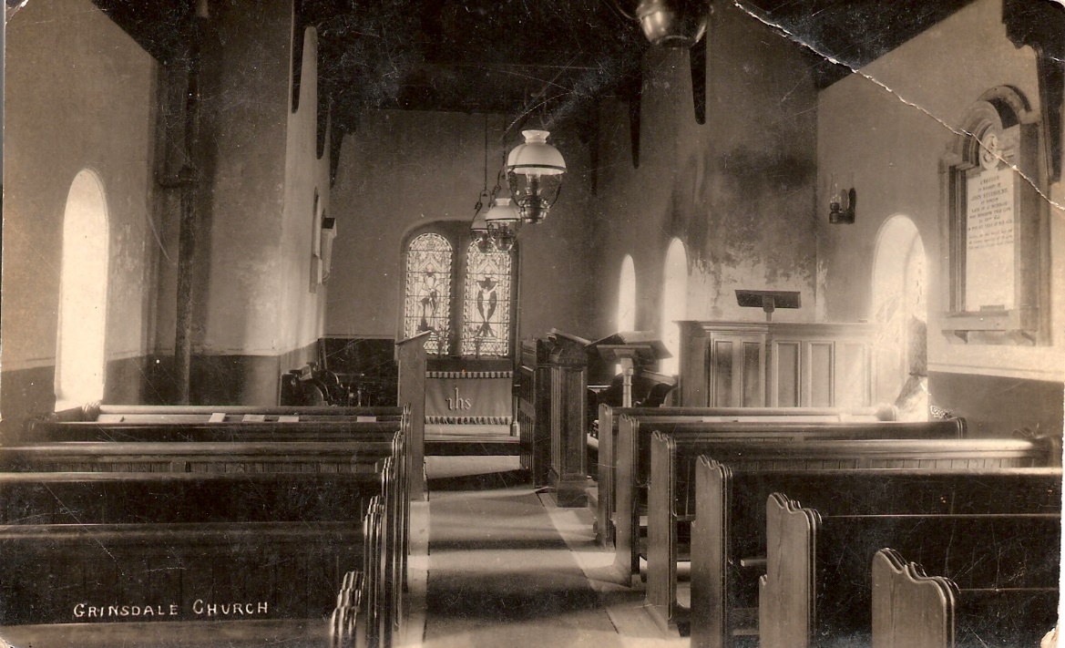

Since 1908 the parish has been a united benefice with the parish of Kirkandrews-on-Eden with Beaumont. Kirkandrews having lost its church united with Beaumont in 1692. In some ways this seems to be the re-uniting of the original parish of Kirksteads.

The Church has Grinsdale has no treasures as such. In 1840, Jonathan Wilson, presented the church with a silver chalice. He was the vicar of St. Kentigern's when he made this gesture. The silver cup is 6 1/2" high and 3 3/4" across the top of the bowl. The diameter across the foot is 3". It has five marks upon it:
1. Lion passant
2. Leopard's Head crowned
3. Small Roman "U"
4. London 1795-64.King's Head.
5. The initials "S.H."
The sacred monogram on one side is a modern audit addition.

The silver plated Paten was given by Revd. Henry Gough, the then incumbent. There is also a Pewter Plate which has the name "Cornhill" stamped on the underside. This may well be a reference to the farm and area known as Cornhill within the parish.

It is interesting to note that the Terriers of 1749 and 1810 make no mention of church plate which probably means that there wasn't any. Could this then mean that Holy Communion was not celebrated? It would appear from a photograph that administration of the sacrament before the Restoration in 1895 was difficult, as already mentioned.
It is also clear from the photograph that there was no cross on the altar. Perhaps the church concentrated on the Ministry of the Word but this is something that we will probably never know. John Stamper makes no mention of plate in his journal and this again is strange if there was any given when the church was first built;

On April 19th, 1981, which was Easter Day, the parish celebrated 240 years of worship in their church with a special Eucharist presided over by the Bishop of Penrith.

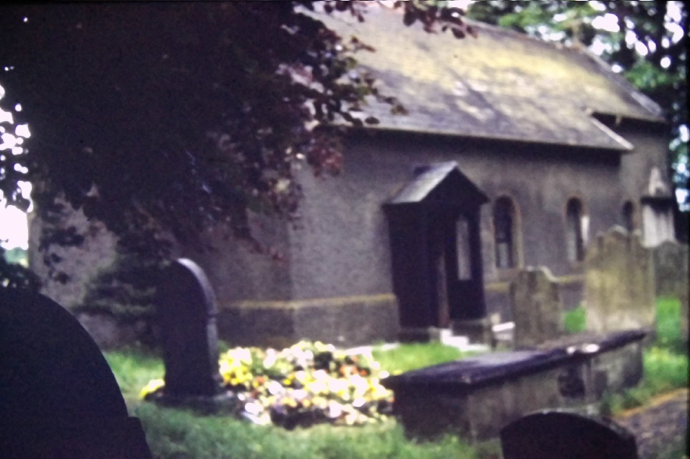

VICARS OF ST. KENTIGERN, GRINSDALE.

1738 John Stamper
1761 William Baty
1777 Thomas Pattinson
1829 Jonathan Wilson
1848 Henry Gough
1855 John Barton Norman
1869 Frances John Allnatt
1895 Matthewman Sidney Donald
1899 Joseph Chapelhow
1915 John Alfred Kitchen
1926 Reginald Samuel Edward Oliver
1948 John Lloyd Crawley
1952 William Hartley
1954 Henry Whiteley
1965 Deryck Barnard Garland

PRIESTS IN CHARGE OF GRINSDALE

1972 David Osborne
1978 Geoffrey Dobson.

Priest in charge of the Barony of Burgh (Combined parishes include Bowness, Burgh-by-Sands, Beaumont, Kirkandrews-on-Eden and Grinsdale, Kirkbampton, Great Orton, and Aikton)

Gill Hart (Rector)
2006 Stewart Fyfe (Curate)
2011 Tudor Boddam-Whetham

