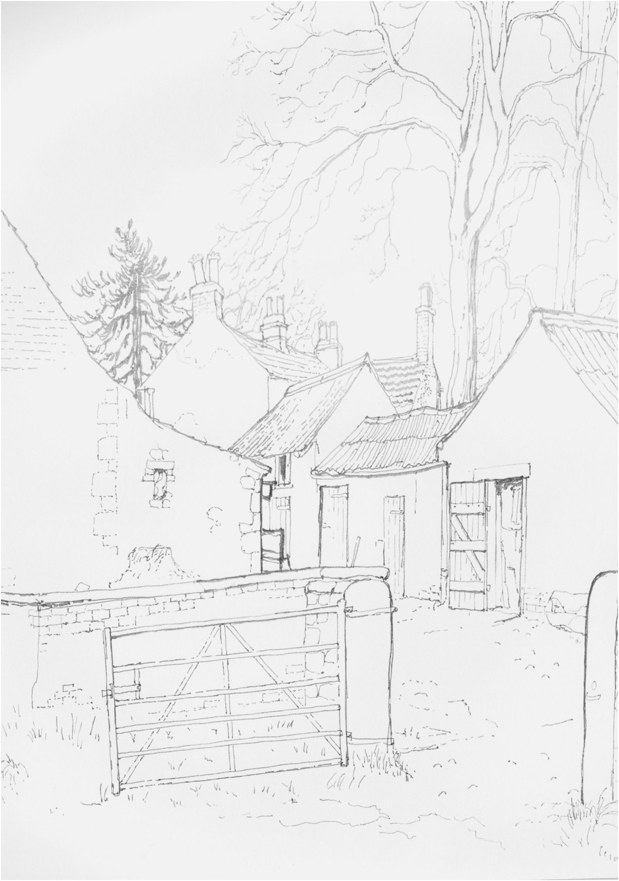
Beaumont Parish

Action Plan

for the Communities of

Beaumont, Grinsdale, Hosket Hill,

Kirkandrews-on-Eden

and Monkhill

2013 to 2018

Contents

Page

Acknowledgements 3

Parish Profile 4
The Consultation Process 6

Survey Results and Analysis

- Overview of Community Satisfaction 7
- Amenities and Personal Development 7
- Environment 12
- Roads and Transport 14
- Policing and Security 17
- Planning 18
- Local Economy 20
- Heritage 22
- Other 24
- Children 28

References 30
Action Plan 31

Appendix 1

- Parish Plan Questionnaire 36

Acknowledgements

Thanks and appreciation to
Hellen Aitken ( ACTion with Communities in Cumbria)
John Collier (Carlisle City Council)
Val Tarbitt (Cumbria County Council)
Trevor Allison (Cumbria County Council)
Beaumont Parish Council;
and to
All the members of the Community who contributed to the creation and production of this Parish Action Plan

The Parish Plan Project Team
The project was carried out by volunteers from the community and the Parish Council

Funding Assistance

This Action Plan was created with financial support from ACT, Cumbria County Council Neighbourhood Forum and Beaumont Parish Council

Illustrations

The illustrations in this document are by kind permission of Mrs Corrine Riley, the family of the late Ann Robinson and the executors of the late Miss Hilda Henderson

Parish Profile

Beaumont Parish is bounded to the North by the River Eden, to the East by the Carlisle City Boundary, to the South and West by the parishes of The Ortons and Burgh by Sands.

The Census of 2010 reveals:-

- A population of 460 residents, including 70 children under 16 and 80 people over 65, living in 180 households.

- A strong feeling of satisfaction with the area as a place in which to live (83%) as well as a confidence (75%) that there is an effective social coherence, (“people get on well together in the local area”)

- A relatively high level of safety, with both perceived and actual criminal issues being lower than the national average.

- A relatively low proportion of deprivation and reliance upon social benefits

- Comparatively good levels of health and low levels of unemployment or economic inactivity

- A balance of educational qualifications and mix of employment on a par with national levels

- A high proportion of houses are owner occupied, detached and above Band C Council Tax rating, but a higher than average proportion of the housing stock is deemed to be energy inefficient.

- There is widespread car ownership, but the availability of rural public transport is poor.

The Parish comprises a traditional rural area, and includes the villages of Beaumont, Grinsdale and Kirkandrews on Eden, together with the hamlets of Monkhill and Hosket Hill and scattered neighbouring properties.

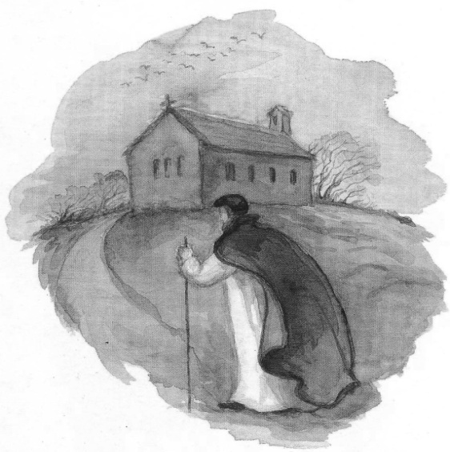
There are no shops or schools within the Parish, and children from the Parish can attend the Primary School at Burgh by Sands (3 miles) and Secondary school at Dalston (6 miles).

The Beaumont Parish Hall is situated in Kirkandrews on Eden, and there is also a Village Hall at Grinsdale. Both Halls have benefitted from considerable up-grading in recent years,

The Church of St. Mary at Beaumont (C of E) is a Grade 2* Listed Building, sited on a Norman ‘Motte’, which itself sits over the site of a Turret of Hadrian’s Wall (World Heritage Site).

There is an active Methodist Chapel at Monkhill, with a fully serviced, annexed social hall building.

The Church of St. Kentigern at Grinsdale (accessed by a bridleway through two fields) was closed for worship in 2001, as a result of Foot and Mouth Disease in the surrounding villages. It is now permanently redundant, awaiting disposal under a scheme for conversion to private dwelling (with public access conditions) which has received outline planning consent from Carlisle City Council.

There is one public house, ‘The Drovers Rest’, in the Parish at Monkhill. This is currently being advertised for sale and has been temporarily closed on several occasions in recent years.

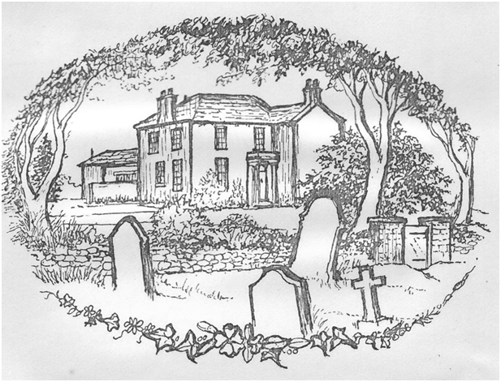
There are two graveyards in the Parish, at Grinsdale and Beaumont, and the Parish Council grants financial support towards the cost of their maintenance. There is also a closed graveyard (maintained by Cumbria County Council) in Kirkandrews on Eden adjacent to the site of the former St Andrews Church (closed in 1750’s and with no visible evidence remaining)

There is a ‘Pound’ in Kirkandrews on Eden and an attractive Village Green (part of the former Norman “Bailey” in Beaumont, both maintained by Beaumont Parish Council.

The River Eden passes the villages of Grinsdale, Kirkandrews on Eden and Beaumont, before exiting into the Solway Firth at Sandsfield, on the Western boundary of the Parish. The river and its banks are classified as a Site of Special Scientific Interest, and the Parish is within an Area of Outstanding Natural Beauty.

The course of the former Hadrian’s Wall (World Heritage Site) transits the Parish through Grinsdale, Kirkandrews on Eden and Beaumont, then crosses the fields directly West of St Mary’s Church towards Burgh by Sands. The opportunities that this presents are taken into account within this Parish Action Plan.

None of the Parish is presently classified as a Conservation Area.

.

The principal occupation of the residents of the Parish, until relatively recent years, was mixed agriculture and, although now offering significantly less employment, this still shapes the area’s character.

The Consultation Process

The Project Team first met in December 2011, and received advice from a representative of Burgh by Sands Parish Council, who had been involved in the creation of their original Plan in 2003, which is now in course of revision.

In February 2012, Hellen Aitken from ACT met the Project Team, and assisted us to structure a Project Programme to consult with the community. This began with 2 Open Meetings, to which all residents were individually invited, in April 2012 in Beaumont Parish Hall.

Those attending the Open Meetings were given a presentation by Hellen about the concepts and advantages of creating Parish Plans, with examples from recent successful projects in rural areas. Many ideas were received from these Open Meetings, and additional members of the community offered to assist on the Project Team.

A further presentation was made during the Parish celebrations of the Jubilee using a manned display stand in Beaumont Parish Hall. Here members of the community were invited to add their comments to those from the open meetings and children were asked to draw their vision for the Parish. The stand was left in place for one month to allow all of the hall’s user groups to contribute.

Analysis of the information gained enabled the creation of a Questionnaire which was distributed by hand to every registered elector (397) in the Parish during October 2012. 17% of the questionnaires (69) were completed and returned in November 2012 and the responses tabulated.

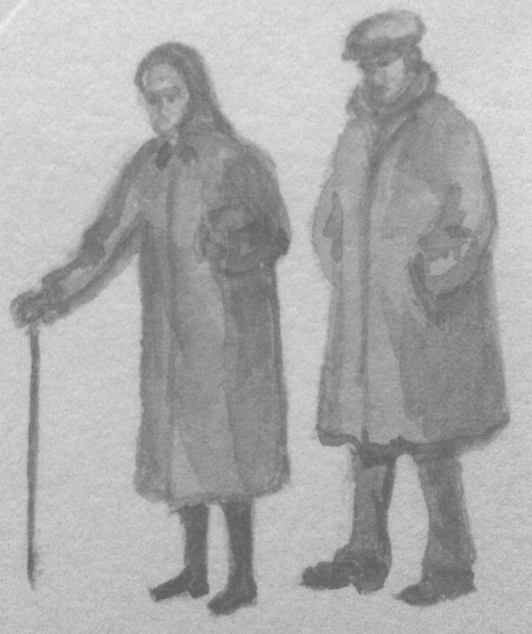
Progress Reports, together with early advice as to the opportunities for general public involvement, were regularly published in monthly editions of “Parish News”, which is delivered, free of charge, to each household within the Parishes of Aikton, Beaumont, Burgh by Sands, Great Orton and Kirkbampton, which comprise the Anglican United Benefice of “The Barony of Burgh”.

The issues, concerns and wishes of respondents to the Public Consultations and Questionnaires have informed the creation of the Parish Action Plan contained herewith. All figures shown in the charts are expressed as a percentage of the total number of respondents to the questionnaire.

Following consultation with Carlisle City Council, Cumbria County Council, ACT, Solway AONB, Cumbria Rural Housing Trust and Hadrian’s Wall Heritage Ltd, the finalised Parish Plan was launched at a “Parish Life” event in Beaumont Parish Hall in July 2013.

Survey Results and Analysis

Overview of Community Satisfaction

Within the October 2012 Parishioners Questionnaire, residents were asked

Q.1 “What do you like most about living in Beaumont Parish?”

The large majority of responders highlighted the quality of an authentically traditional, rural life and environment, complemented by the proximity to the urban district of Carlisle and its facilities.

Residents were then asked

Q.2 “What do you like least about living in the Parish?”

The large majority of comments reflected concerns regarding traffic issues and the inadequacy of the rural road system and its maintenance.

Amenities and Personal Development

Q.3 asked respondents if they use the community halls and how they could be better used
Beaumont Parish Hall (Tel 01228 576403 for bookings)
This wooden hut (with later brick built extensions) was purchased following World War Two and was officially opened in 1953 to celebrate the Queen’s coronation. Beaumont Parish Hall is well used locally, hosting play groups, community groups and social events. There is disabled parking and access and the hall is also hired out for private social activities. The main hall incorporates a stage and dance floor and there are kitchen and toilet facilities. Outside, there are tennis courts, a play area, picnic area and playing field adjacent to the hall. The Parish Council arranges and funds the grass cutting of this field. The Hall Committee are responsible for maintaining the hall and they arrange many of the social functions. 86% of respondents said that they use the hall. (Fig 1)
Figure 1

Grinsdale Village Hall (Tel 01228 549582 for bookings)
The original wooden hut, known as the local reading room, was burnt down and a new brick Hall was constructed in the 1930’s. Grinsdale Village Hall was popular as a dance hall and accommodated the local Young Farmers Club; whist drives and coffee evenings were held to raise funds for the upkeep of the hall. It was recently refurbished and now features a fully licensed bar, a new catering kitchen and disabled facilities. It also has a grassed area and car parking space. It is currently used as a rehearsal space for local musicians, a venue for

community groups and it is booked for birthday celebrations and fund raising events. Only 29% of respondents make use of Grinsdale Village Hall (Fig 2.)

Figure 2

There was a wide variety of suggestions for additional use of the halls. (Fig 3)
Figure 3

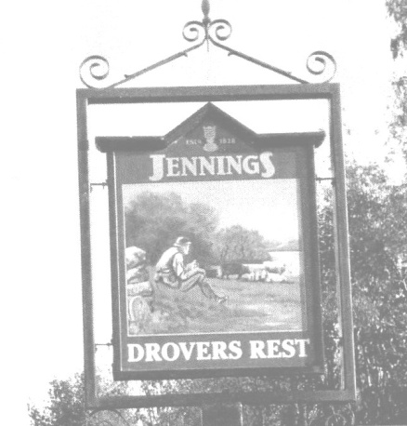
Public House
Figure 3
Q4 asked if respondents make use of the local pub, The Drovers Rest, in the village of Monkhill. This was a former barn and stables and is a listed building which once belonged to the Carlisle and District State Management Scheme (until its dissolution in 1973). It hosted darts, pool and domino teams and was the hub of the Parish. It has a large grassed area at the rear. In recent times there has been a rapid turnover of landlords, the pub no longer offers food, and it is currently being offered for freehold sale. 60% of respondents said that they do not use the pub and gave a variety of suggestions as to what to do to revive the hostelry, the principal one being the provision of good food at reasonable prices.
Library Link
Beaumont Parish is served by the main Carlisle City Library which has an outlying part-time library facility at Morton Community Centre.
In addition, there is a mobile library service which visits the villages every 5-6 weeks, following a route through Grinsdale, Kirkandrews, Beaumont, Monkhill and Moorhouse. It stops in each village for approximately 10 minutes. Although this service is appreciated by those who use it, it does not serve properties off the route, such as Hosket Hill and is not at a time which is useful for those parishioners who work full time or are at school during the day. Q5 asked respondents if they would make use of a library link in the parish. 94% replied and of these 46% said yes and 48% said no.

Facilities
Beaumont Parish is a relatively low density population area and has few facilities. In question 6, respondents were asked to consider what facilities they would like to see for the different age groups within the population.
Pre-school
There are currently no facilities specifically for children between 0 and 3 in the parish. There is a play area outside Beaumont Parish Hall which has some equipment suitable for this age group.
Children and young people
A youth club, which accommodates primary age children, operates on Monday evenings in Beaumont Parish Hall. There are 2 pieces of equipment in the play area suitable for this age group and there has been a summer play scheme held in the Parish Hall for a few days each year.
The main suggestions for amenities for young children were dance and gymnastics clubs, better play area facilities (including a safe area for cycling, slide, zip wire and goal posts), and a play group for pre-school children.
There are no facilities for teenagers in the parish. The main suggestions received were for more social gathering areas including a senior youth club, more organised activities and a place for skateboarding.
Adults
A variety of clubs and classes are held in the various social gathering places in the parish, including Women’s Institute, Flower Club, Local History Society, Tennis Club, Dance Classes, coffee mornings and lunches. Many parishioners suggested that they would like more of these social/ community events and, in particular, more things during the daytime. Classes in keep fit, handicrafts and computing were also popular suggestions.
Adults of all ages mentioned improving the bus service, but this was one of the priorities for older residents.
The pub was also suggested as a potential venue for other activities.
Tourists
Tourism is becoming an increasing feature of life in the parish and there were a lot of suggestions for amenities which might be helpful for tourists. These are shown in Fig 4:

Figure 4

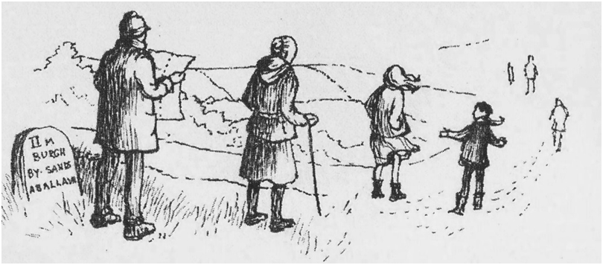
Q7 asked respondents if they use the tennis courts and play area and how they could be improved.

Tennis courts
There are two grass tennis courts and a tennis pavilion at Beaumont Parish Hall which are run by the Tennis Club. Parishioners of any age can join the club by paying a subscription for their membership. The club hold an open day with barbecue each year and historically have offered tennis coaching for young people in the club. The facilities are maintained by the members of the club, but have latterly suffered from lack of use due to low membership. 86 % of respondents do not use the tennis club, although some have done so in the past and have now stopped. Several respondents said that they would like to use the courts and gave a variety of suggestions as to how this might be achieved. (Fig 5)

Figure 5

Play area
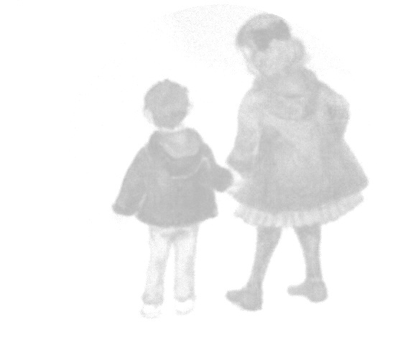
The Parish Hall also has a large playing field and a children’s playground. One third of respondents use, have used, or are planning to use the playground. This facility is owned and maintained by the Parish Hall Committee with financial assistance from the Parish Council. All of the suggestions for developing the playground centred on improving the play equipment. The Parish Council also has concerns that all of the Parish’s play equipment is at Beaumont Parish Hall, which, being some distance from the other villages, could make it hard for many children to access these facilities. Some residents also noted that there were no play facilities at Grinsdale.

Access for all
Because of the rural nature of Beaumont Parish, there is little provision for those with reduced mobility. There are very few pavements, which are often too narrow for wheelchair or pushchair use, and the roads tend to be narrow and often wet and muddy. In Q8, parishioners were asked if they were aware of any places in the parish that would benefit from being made more accessible to wheelchair and pushchair users. Respondents made the following suggestions: Fig 6
Figure 6

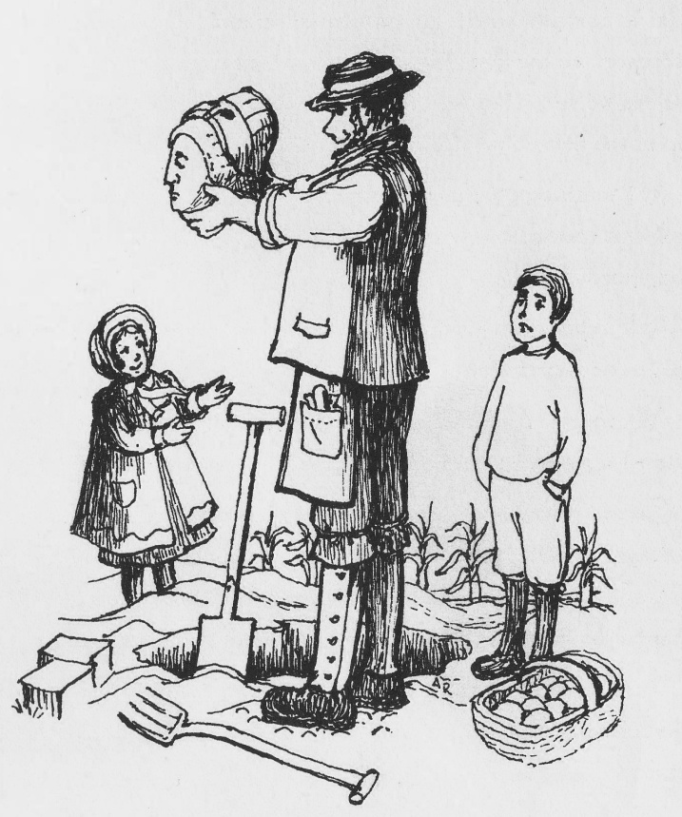
Waste collection and recycling

The Parish has recycling bins in Grinsdale and, until recently, had a second site in the Drovers Rest car park at Monkhill. Dustbins are emptied on alternate weeks with general waste and recyclable materials being taken one week and green garden waste being taken the next. In Q9, 65% of respondents said that they were satisfied with the waste collection and recycling facilities in the Parish, although 14% were unhappy that the pub recycling bins had been removed. There were complaints about the litter dropped by bin collectors, missed collections and the lack of some collections of recyclable materials at Hosket Hill and Ratlingate. Parishioners also commented that they would like collections of foil, batteries and plastics for recycling.

Environment

Q10 asked residents to suggest what the grassed area known as “The Pound” in Kirkandrews could be used for. It was interesting that the presence of the pound was not known to some. A high number of people favoured selling the Pound but overall, the majority of respondents favoured its re-modelling. This would involve improving the visibility of this facility and increasing its usefulness and respondents’ suggestions are shown in Fig 7 below.

Figure 7

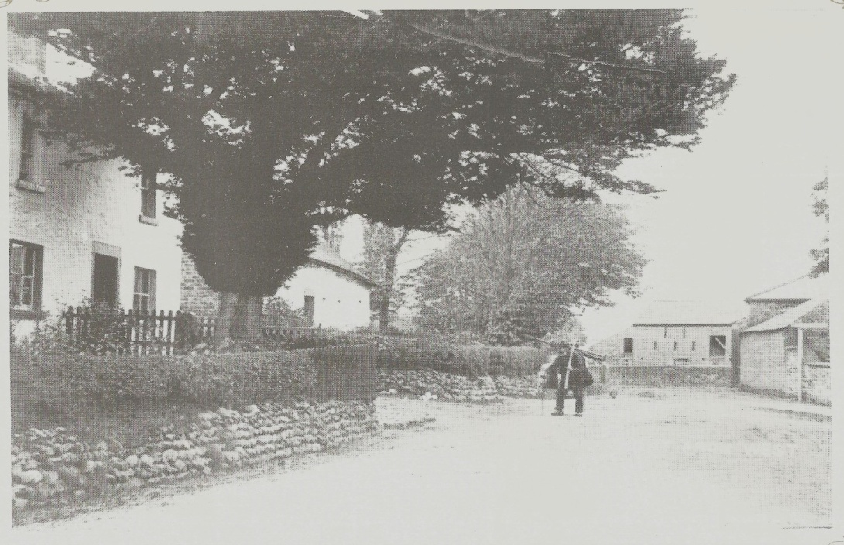
The Mole Catcher -Beaumont
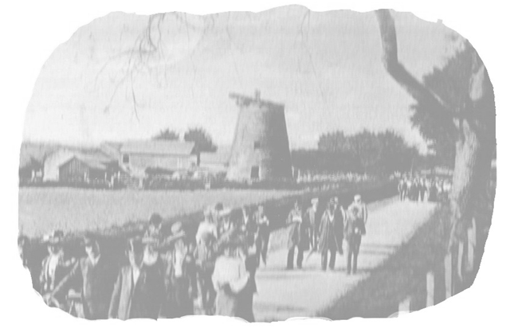

Question 11 asked how we can improve the experience of tourists and visitors to the Parish. E.g. appearance, facilities, information. A total of 65 responses were received for this question, with a wide variety of suggestions, which can be seen in Fig 8 below.

Monkhill Windmill
Figure 8

These suggestions have been grouped into broader categories in Fig 9 below

Figure 9

The largest categories were the provision of information and facilities, covering guidance and local history, improved facilities, toilets and accommodation. In addition, the general appearance of the parish was also viewed as important from both a tourist and residential view point. As with the Pound, a number of suggestions have been received which need to be considered by the Parish Council.

Roads & Transport

The Parish has direct road links into Carlisle, and has recently been connected to the north of the River Eden via the A689 Carlisle Northern Development Route. The Parish has a number of minor roads running through it; each carrying significant amounts of traffic to and from the adjacent villages and western reaches of the Solway plain. In recent years, the quantity and size of vehicles travelling from Carlisle via Grinsdale Bridge, Kirkandrews and Monkhill towards Burgh-by-Sands have increased markedly. Large lorries and farm vehicles regularly have difficulty passing a similar sized vehicle coming the other way. This situation usually results in one or both vehicles riding up the grass verge resulting in dirt/mud being spread on the road, increasing danger of skidding to other users, damage to the roadside environment and reducing road safety.

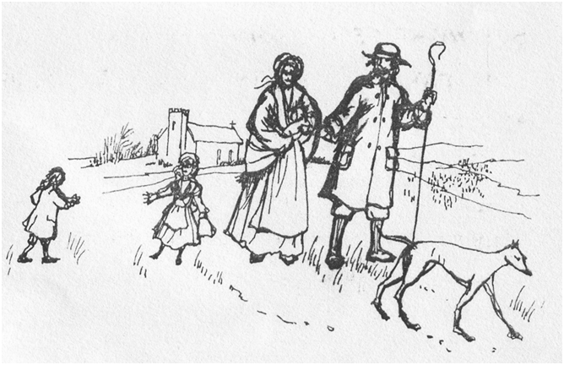
Q12 asked if any issues on our roads need special consideration. 75% of returned questionnaires stated that the whole road network throughout the Parish requires special consideration, particularly with regard to speed limits and traffic calming. The poor condition of some roads, including potholes, blocked road drains and dirt was also highlighted by respondents. (Fig 10)

Figure 10

In question 13, parishioners were asked if they encountered difficulties due to lack of public transport. Of those who responded, 27% said “Yes” and 38 % said “No”. 35% of respondents do not use public transport.
The bus service was considered inadequate by those who sought to use it, with infrequent service, or unsuitable time-tabling being quoted. Lack of buses outside “core” times (evenings or weekends) was also highlighted (Fig 11)

Figure 11

In Q14 parishioners were asked whether they felt that they needed more pavements. Of those who responded, 42% said “Yes” and 58% said “No”.

Respondents expressed the opinion that the following areas needed more pavements (Fig12)
Figure 12

Policing and security
Beaumont Parish is an area of low incidence of crime. Q16 asked parishioners if they had any concerns about the levels of local policing and/or emergency service response. 63% of respondents reported that they had no concerns. The main view expressed was that greater police visibility would be reassuring, especially to those in more remote dwellings.

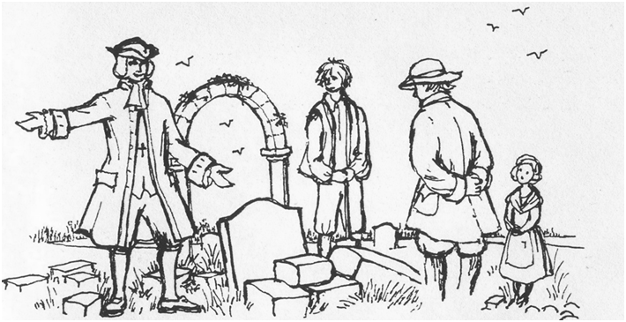

Street lighting
The majority of people throughout the parish considered that the level of street lighting was about right (Fig 13)

Figure 13

Planning

Q17 asked what should be protected from change The majority view is that we need to retain the character and rural feel of the villages, promoting the community spirit that makes rural life attractive and ensuring that we preserve our local heritage sites/ churches / trees etc (Fig 14)

Figure 14

Q18 asked parishioners how and where we can provide suitable and affordable homes for young people and older residents in the Parish. The need for low cost housing for both the young and the older generation is apparent, with 35 respondents making many suggestions as to how this might be achieved (Fig 15). However, the feasibility of these could be dependent on local site availability, Local Authority support and input from Cumbria Rural Housing Trust.

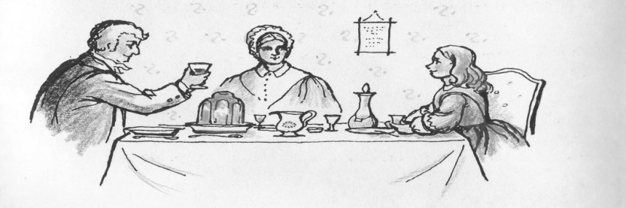

Figure 15

There were only 12 responses to question 19 covering facilities for local business and 42% of these highlighted the need for “better internet speed” (Fig 16). However, the returns from questions 20 and 21, which totalled 62 and 45 responses respectively, demonstrate that this area was important not only to businesses but to the general public at large. The parish is involved in the County Council “Broadband for Cumbria” project to bring high speed fibre-optic broadband to Cumbria and will use the information from the returns to inform that project.

Figure 16

Q20. Is reliable broadband important to you? (Fig 17)

Q21. Are you satisfied with your existing Broadband service? (Fig 18)

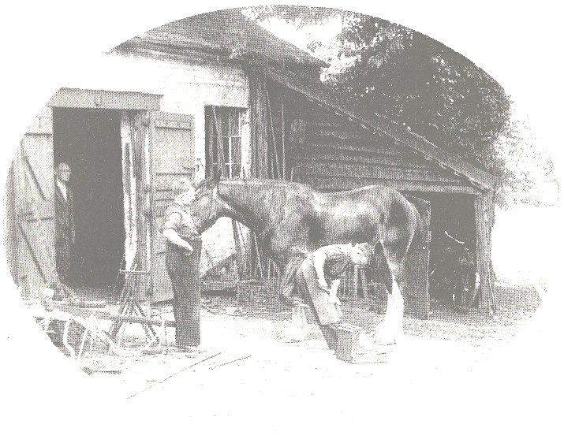
Local Economy

The Parish and its surrounding area have a thriving network of local small businesses, often run by self-employed parishioners, providing a wide range of services and amenities. There is easy access to Carlisle and other towns which offer availability of larger scale business and services. Q22 asked parishioners about their use of local businesses. 65% of respondents use local businesses (Fig 19) and the majority find out about these services from the parish magazine (Fig 20)
The Forge –Kirkandrews on Eden
Figure 19

Figure 20

The Parish is situated within an Area of Outstanding Natural Beauty, but there is only limited provision of catered accommodation within the Parish for visitors and tourists.
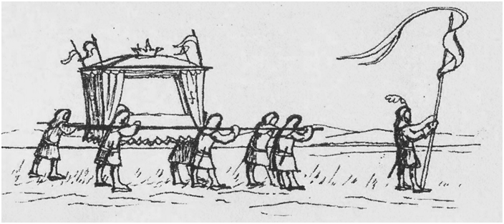

Q23 asked how the parish can benefit from tourism and 81% of respondents gave a view on this question; the majority indicating that resources and income in the Parish would be improved by increased numbers of visitors. Approximately 7% felt that there would be no effect, whilst 5% felt that there would be detrimental effects from increased tourism. There were various suggestions for enhancing provision for visitors; however there also was concern that increased visitors would bring attendant problems of increased traffic, litter and parking. (Fig 21)

Figure 21

Heritage
Church and Chapel
The Anglican Church of St Mary’s in Beaumont is linked to 4 other churches to form the United Benefice of the Barony of Burgh. The building was constructed in the late 13th century (largely of stone from Hadrian’s Wall) and has been a place of worship for over 700 years. It is of major historical interest. Services are held regularly and the Parochial Church Council organises social and fund raising events.
The Methodist Chapel in Monkhill is part of the Carlisle Circuit with services held weekly. The Chapel’s Council arrange a regular programme of events including fellowship, coffee mornings and lunches. The school-room adjoining the Chapel is available for bookings by small groups and meetings.
The Church and Chapel occasionally unite for shared services and other events.
St Kentigern’s Church in Grinsdale is now redundant, although the churchyard remains open for burials.
Q24 asked how the Church and Chapel buildings could be integrated into village life and there were many suggestions. (Fig 22)
Figure 22

Cultural, industrial and historical heritage.

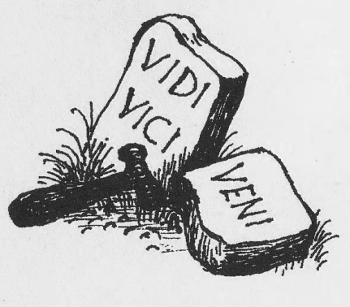
The parish is steeped in history and we are surrounded by evidence of the lives of people from The Stone Age, the Romans, the Border Reivers, through to the Industrial Revolution. The area along the course of Hadrian’s Wall has, in recent years, attracted a greatly increasing number of visitors, either walking the route of Wall, or using the Hadrian’s Way National Cycle Trail. In addition, the course of the former canal from Port Carlisle to Carlisle (later adapted to form the track bed of the Carlisle to Silloth branch railway line) passes through the Parish, and there is still evidence of the industry and heritage buildings relating to it

41% of respondents to Q25 support increased awareness of the heritage of the parish with the majority in favour of leaflets and information boards. (Fig 23)

Figure 23

Other

The Parish Council is creating a Parish Website and Q26 asked what information should be included. The diversity of responses (Fig 24) indicates that a Parish Website would be seen as a popular facility with respondents identifying many areas that they would like to see included, such as information on local trades, interest groups, transport, walks and maps. The challenge for the Parish council will be to balance the requests with practicality and to ensure that the Website complements the much respected Parish Magazine
Figure 24

Q27 asked parishioners what they think are the most important issues for the Parish to tackle. As might be expected this section gathered issues / comment covering all areas, feed back as shown in Fig 25 demonstrates the need to consider the following;

Figure 25

- The lack of infrastructure maintenance, with roads, pavements, persistent flooding and a lack of ditch maintenance considered as major issues
- Resistance to anything which detracts from the natural beauty of the area, e.g. windmills, pylons, litter and fly-tipping.
- Low cost housing to retain and attract young /single/ elderly people.
- Making public transport more useful to parishioners.
- Road safety and maintenance were a major concern.
- The provision of information about all areas of the Parish, specifically the church, details of local tradesmen and information for tourists in the form of maps and walks and signage. (Fig 26)

Figure 26

Figure 26

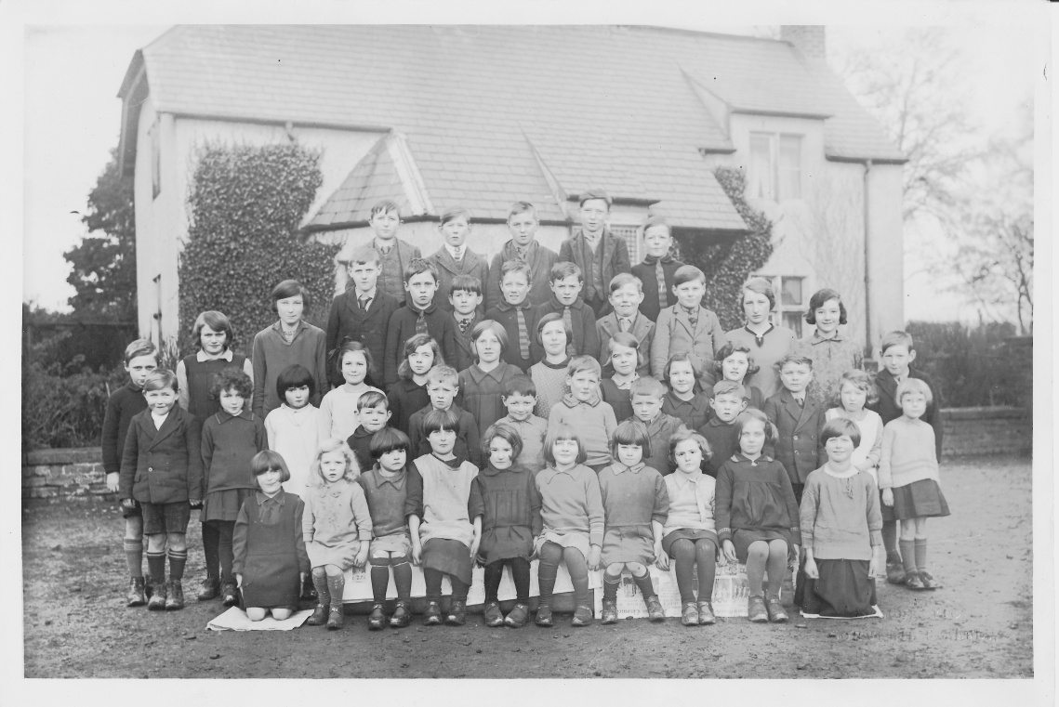
Children

Children of Kirkandrews on Eden School -approximately 1929
The survey sought suggestions from children as to how they would see the Parish improved with Q.28 asking “If you were King or Queen for the day, what one thing would you change or improve in the parish?” There were 9 replies from the questionnaire. (Fig 27)

Figure 27

At the public meetings the children were also encouraged to draw pictures showing what they would like to see addressed, and the list below summarises the themes of the pictures.

- Potholes Shop
- Swings at Grinsdale Ice cream van
- Path from Grinsdale to Hall Slide at Village Hall
- Trampoline Grass
- Flowers Green refuse bin at Beaumont
- New ivy-free wall at Beaumont Flowers at Beaumont
- Pavement at Beaumont Hill Cafe
- Birds and Butterflies Street lamp across from Harry’s House

The responses mirrored the adult comments in terms of improved road conditions, more pavements and reduced dirt/litter. Several children also made specific requests for a visiting ice cream van; more play facilities; a skate park; and for more flowers in public areas.

References
Rural Community Profile for Beaumont (Parish), Action with Communities in Rural England (ACRE) Rural evidence project January 2012

Action Plan
Ref |  | Issue | Action | Partners | Timescale | Priority
AP01 |  | Produce a Community Action Plan | Develop a focus group to take the following initiatives forward | Members of the Parish council and volunteers from the community. | Lifetime of Plan | H
AP02 |  | Produce a Full Plan | Full Copy to be available in hard copy with Parish Clerk and in village halls. Electronic copy on Parish website | Copies also to be lodged with Local Authority and other relevant public bodies | July 2013 | H
AP03 |  | Distribute Plan | Distribute a Summary copy of the Parish Plan to each household in Parish. Distribution to be advertised in Parish Magazine and personalised envelopes to be prepared with covering letter. | Distribution team from Parish Plan Group. | July 2013 | H
AP04 |  | Launch Plan | Present full Parish Plan to public with opportunities for questions as part of Parish Event in Beaumont Parish Hall | Parish Hall Committee and Parish Plan Group, | July 2013 | H
Amenities & Personal Development Q3-9

APD01 |  | Increase use of parish halls | Discuss proposed uses of the halls with relevant organisations within the parish | Hall Committees and other village committees. | 2013/4 | M
APD02 |  | Increase use of Drovers Rest | Discuss finding of survey with new publican. | New publican. | 2013/4 | M
APD03 |  | Improve access to Library facilities | Publicise library van in the Parish magazine and notice boards and discuss library facilities with County Council s | County Council. | 2014 | M
APD04 | Parish facilities
APD04a |  | Improve facilities for Children and Young people | Parish Council to consult with parishioners, Village Hall Committees and other Villages on provision of play equipment, Mother and Toddler group and Social Activities | Village Hall Committees  Other Villages in the area | Lifetime of plan | M
APD04b |  | Improve facilities for Adults | Parish Council to encourage groups running classes and activities to advertise activities more | Consult with parishioners,  Hall Committees  Other Villages | 2014 | M
APD04c |  | Improve public transport | Bus services | See roads and transport RT02
APD04d |  | Improve information for Tourists | Parish Council to initiate the development of information boards and signage | Hadrian’s Wall Trust, Natural England & Solway AONB. | Autumn2013 then ongoing | H
Ref |  | Issue | Action | Partners | Timescale | Priority
APD04e |  | Provide toilets and refreshments for tourists | Parish Council to discuss the feasibility of providing toilets and refreshments. | Hadrian’s Wall Trust | Autumn 2014 -ongoing | H
APD04f |  | Provide information online for tourists | Parish Council to consider needs of tourists during website development | Website developer  Hadrian’s Wall Trust | Spring 2014 | H
APD04g |  | Provide benches and car parking for tourists | PC to discuss the provision of car parking and seating in the Parish |  | Ongoing | L
APD05a |  | Improve tennis courts to make a more usable community facility | Parish Council to discuss with the Parish Hall Committee | Parish hall Committee | Ongoing | M
APD05b |  | Improve access to the play area | Parish Council to discuss provision of a path to the play area with the Parish Hall Committee | Parish Hall Committee | Autumn 2013 | L
APD06 |  | Improve wheelchair and  pushchair accessibility | Discuss access issues with relevant organisations and represent view of parishioners to bus company | Highways Department  Bus Companies | Lifetime of plan | M
APD07 |  | Improve refuse and recycling services throughout the Parish | Parish Council to monitor and contact City Council as necessary to ensure consistency of service throughout the parish  Contact City Council ref recycling bins in pub car park | City Council  Parishioners | 2013  Life of plan | M
Environment Q10-11

E01 |  | Make use of the Pound | Parish Council to instigate a Group of interested parties responsible for developing a practical plan and to review proposals from this group to ensure practicality, cost and sustainability and to assist in obtaining funding | Parishioners  Groundwork | 2014 | M
E02 |  | Improve the experience of tourists and visitors | Parish council to instigate a Tourism Group to develop viable schemes of improvement and liaise with established organisations  Group to report to Parish Council, who will assist with obtaining funding | Burgh Tourism Group for assistance.  Involve relevant tourism promotion organisations. | 18 months  Then ongoing | M
Ref |  | Issue | Action | Partners | Timescale | Priority
E03 |  | Involve the church and chapel more in community life. | Parish Council to discuss findings with Church and Chapel  See Heritage H01 | “Sustainable Churches” initiative. | 12 months  Ongoing | M
Roads & Transport Q12-14

RT01 |  | Improve the maintenance of roads | Parish Council to actively seek consultation with the Highways Department with a view to a public meeting within the parish | County Councillor  Highways Department  Parishioners | Summer 2013  ongoing | H
RT02 |  | Make public transport more useful. | Parish Council to discuss public funding options with adjacent/ connecting Parish Councils in order to increase potential for improved bus services and other public transport options. Advertise Rural wheels locally | Burgh By Sands Parish Council | 2014 and ongoing | H
RT03 |  | Improve the provision and maintenance of pavements | Consideration to be given to pavement provision as part of consultation with the Highways Department | Highways department | Lifetime of plan | H
Policing and security Q16-17

PS01 |  | Increase the visibility of policing. | Parish Council to pass findings of the questionnaire to the Neighbourhood Policing Team | Neighbourhood Policing Team | 2013 | M
PS02 |  | Improve neighbourhood security. | Parish Council will actively encourage the re-establishment of the Neighbourhood Watch Scheme | Neighbourhood Watch Coordinator | 2013 | M
PS03 |  | Provide more street lighting in specific areas. | Parish Council to address specific concerns about street lighting within areas of the Parish  Follow up with County Council | Parishioners  County Council | 2014 | L
Planning Q18-21

P01 |  | Improve control of new developments and provide some affordable housing. | Parish Council to consult with City Council Planning Dept to create a shared development position based on Parish Plan findings and Carlisle Development Plan May address the currently poor response by the Local Authority to Parish Council’s legitimate observations on sensitive Planning Applications | Carlisle City Council Planning Department  Cumbria Rural Housing Trust | 2013  Ongoing | H
Ref |  | Issue | Action | Partners | Timescale | Priority
P02 |  | Encourage and support facilities that would be beneficial to our local businesses | Parish Broadband Champion to seek confirmation of Parish’s status within the main Cumbria plan.  Website to promote awareness of local businesses and support services. | Broadband Champion  Cumbria County Council  CALC | 2013  Then ongoing | M
P03 |  | Improve broadband performance | To be progressed as part of P02 above | Connecting Cumbria | 2014  Then ongoing | M
Q22-23 Local Economy

LE01 |  | Encourage the local economy | Parish Council to encourage local businesses to continue to use the Parish Magazine to advertise their services, and parishioners to make use of the magazine and parish website. |  | Lifetime of plan | M
LE01 |  | Support the growth of sustainable tourism | The Parish Council will promote tourism in the parish whilst maintaining the local environment | Hadrian’s Wall Trust  Natural England, Solway AONB,  Burgh Tourism Group | Lifetime of Plan | M
Heritage Q24-25

H01 |  | Promote the church and chapel as centres of local heritage. | Parish Council to pass findings of questionnaire to PCC and Methodist Chapel  See Environment E03 |  | Autumn 2013 | M
H02 |  | Industrial heritage
H02a |  | Provide information and signs to promote sites of local historical interest. | Parish Council to consult with Local History Society, Hadrian’s Wall heritage Ltd and Burgh Tourism group to find funding and suitable material to be included | Local History Society  Burgh by Sands Tourism Group  Solway AONB  Hadrian’s Wall Trust | Autumn 2013 | H
H02b |  | Develop a parish leaflet to provide information on the area | Parish Council to consult with Local History Society | Local History Society | Autumn 2013 and ongoing | M
H02c |  | Encourage events, talks, site visits,  classes and promotion of the local area | Parish Council to consult with Local History group and consult with parishioners via website about what is required and what is available. | Local History Society  Parishioners | Autumn 2013 | M
Ref |  | Issue | Action | Partners | Timescale | Priority
H02d |  | Provide more information about walking routes in the area. | Parish Council to initiate development of leaflets, use of website | Local media,  Tourist Organisations  Parishioners | 2013 and ongoing | M
Other Q26-27

OT01 |  | Develop a parish website | PC to use suggestions for website from the questionnaire to inform its development.  PC to decide the method of ongoing management. | Website developer | 2013 | H
OT02 |  | Prioritise issues which parishioners consider the most important. | Parish Council to report findings to other relevant authorities and to act independently on areas within their control  There is a range of issues across a wide area which the Parish Council needs to address This requires a practical plan of achievable and affordable outcomes and will need small groups of volunteers to carry them out, | Highways Department  Environment Department  Planning Department  Volunteers from the Parish | 2013  Then ongoing | H
Children Q28

C01a |  | Improve play facilities | Seek funding for improved play facilities | Cumbria County Council  Carlisle City Council  Other charitable funding organisations | 2014 | M
C01b |  | Improve the appearance and accessibility of the environment | Plant more bulbs around the parish  Improve the appearance of the Parish | Volunteers from the Parish | Ongoing | M
CO1c |  | Obtain services of ice cream van | PC to contact local ice cream service |  | 2013 | M

Appendix 1
Creation of a plan for the Beaumont Parish Community

What is it?

The Government’s Rural White Paper ‘Our Countryside –The Future’ (Nov 2000) launched the concept of Parish Plans and outlined their purpose which was to:

- Set out a vision of what is important;
- Find how to preserve valued local features and to map out the facilities which the community needs to safeguard for the future;
- Identify key facilities and services;
- Set out the problems that need to be tackled;
- Demonstrate how distinctive character and features can be preserved.

Why do we need a plan?

The Parish of Beaumont covers an area defined by Bunkers Hill, Moorhouse Road, Hosket Hill, New Sandsfield, Holmes Mill, and Knockupworth and includes the villages of Beaumont, Grinsdale, Hosket Hill, Monkhill and Kirkandrews on Eden
The completed Parish Plan will help us, as a community, shape the future of our Parish and help us to influence both City and County Council decisions in relation to its development.
It can be used to influence a wide range of organisations that provide services and funding to rural communities.

How does the Plan come into being?

The Parish Council has set up a working party of councillors and volunteers from the parish to ask the parishioners what they would like to see in our community in the future.
Two public consultation meetings were held and a display stand was put into the Parish Hall for a month to obtain responses from as many people as possible.
All the views expressed were collated and have led to the development of this questionnaire which is being circulated to all households and organisations in the parish.
By completing this questionnaire you will be making sure that your views will be known and that the working party will be able to continue the development of the Parish Plan knowing that they have understood your views and have a mandate to continue.
Each completed questionnaire will be eligible for entry into a prize draw
Any information collected in the questionnaire will be used only to assist in designing
our Parish Plan and its source will not be disclosed to any third party.

What will happen when the questionnaire is returned?

The answers and comments from each question will be analysed and used to produce a draft of the Parish Plan with a summary of the feedback.
This draft will be available to view and for you to comment on at a Parish Meeting to be notified in the Parish Magazine. It will then be revised as necessary and agreed.
An Action Plan will be created to instruct and inform the Parish Council and other community groups as to the actions needed to further the items in the Parish Plan.
The Plan and Action Plan will be shared with the City and County Councils, and any organisation identified in the delivery of the action plan, for their comment prior to publication.

If you would like to complete this document by email please request an electronic copy from:

beaumontparishplan@hotmail.co.uk

In order to help us analyse the responses, we would be grateful if one person per household could complete this section. Please highlight the gender and ages of all people in your household.

Age group | 0-3 | 4-11 | 12-18 | 19-25 | 26-35 | 36-45 | 46-55 | 56-65 | 65+
Male
Female

Please continue overleaf or on a separate sheet of paper if you would like to make your answers longer or have any other comments that you would like to make.
1. What do you like most about living in Beaumont Parish?

2. What do you like least about living in the parish?

Amenities and Personal Development

Yes |  | No
3. Do you make use of Beaumont Parish Hall?
Yes |  | No
Grinsdale Village Hall
How could they be better used?

Yes |  | No
4. Do you use the pub at Monkhill? If not, what would persuade you to do so?

Yes |  | No
5. Would you make use of a Carlisle City Library link in the parish?
6. What amenities would you make use of, or like to see for the following groups:
Children 0-3
Children 4-11:
Teenagers:
Adults:
Senior Citizens:
Tourists:

Yes |  | No
7. Do you use: a) the tennis courts?

Yes |  | No
b) the playground?

Are they satisfactory and if not, how could they be improved?

Yes |  | No
8. Is there anywhere in the parish that needs improved access for wheelchairs
or pushchairs?

If yes, where do you suggest?

Yes |  | No
9. Are you satisfied with the Council waste disposal and recycling facilities?
If not, how could they be improved?

Environment

10. What do you suggest that we use the Pound in Kirkandrews for?

11. How can we improve the experience of tourists and visitors to the Parish? E.g. Appearance, facilities, information

Roads and transport

Many parishioners have expressed concern about road safety in the Parish.

Yes |  | No
12. Are there any areas that you feel need special consideration?
If yes, please state what/where

Yes |  | No |  | N/A
13. Do you have difficulty in making any journeys due to lack of public transport?

If yes, please give details.

Yes |  | No

14. Do we need more pavements?

If so, where?

Policing and security

Too much
Too little
About right
15. Is the existing street lighting

16. In your experience, have you any concerns about the levels of local
Yes |  | No
policing and/or emergency service response.
Please give details

Planning

17. What do you think should be protected from change?

18. How and where can we provide suitable and affordable homes for young people and older residents in the Parish?

19. If you are (or would like to be) self-employed or run a small local business, what extra facilities would assist you?

Yes |  | No
20. Is reliable broadband important to you?
Yes |  | No
21. Are you satisfied with your existing Broadband service?

Local Economy

A relatively large proportion of working adults in the parish is self employed or has a workplace within the parish.

Yes |  | No
22. Do you use local businesses?
If yes, please state which ones and how you found out about them.

23. How can the parish benefit from tourism?

Heritage;

24. How can the church and chapel buildings and facilities be more fully integrated into village life?

Yes |  | No
25. Should we increase awareness of the cultural, industrial and
historical heritage of the parish?

If so, how?

Other

26. The Parish Council will be creating and maintaining a Parish Website. What information should be included that would be useful to you?

27. What do you think are the most important issues for us to tackle in the parish?

One for the children to answer!

28. If you were the King or Queen for the day, what one thing would you change or improve in the parish?

If you wish to be entered into the prize draw then please provide a name & address, phone number or e mail address below. This piece of the completed questionnaire will then be entered into the draw.

Thank you for taking the time to answer these questions.

Please return your form by SATURDAY 15th DECEMBER to any of the following:

Hollow Creek Farm, Kirkandrews on Eden Ratlingate Farm, Kirkandrews on Eden
The Coach House, Kirkandrews on Eden Romanway, Beaumont
The Hollies, Grinsdale Reservoir Gardens, Moorhouse Road
Monkhill Hall, Monkhill

Or by email to: beaumontparishplan@hotmail.co.uk

Please continue in this space if necessary. Do not write below the line.

