Revamp of the disused tennis courts and pavilion into a wildlife area

Beaumont Parish Hall Management Committee have been considering a solution to the old tennis courts that are situated in the hall grounds which, since they stopped being used, have deteriorated to a poor state and become an eyesore.

The initial plan was to explore replacing the grass courts with an all-weather multi-use pitch, but this has not been achievable for two main reasons:
1. The Cost: Estimates have been obtained from specialist companies that put the price at around £100,000 to £150,000. Such a huge capital cost is not realistic and would probably be very difficult to raise.
2. Dealing with the archaeology: The courts are situated directly on the World Heritage Site, which would not only restrict what could be built, but dealing with the archaeology could also cost tens of thousands of pounds.

Having given it further thought the committee are now exploring the possibility of developing the courts into a community wildlife area. This would:
1. Give an identity and purpose to the area.
2. Provide a space that the community and visitors will be able to enjoy.
3. The costs will be realistic and achievable, and potential funding streams are currently being explored.
4. Have minimal impact on the archaeology.

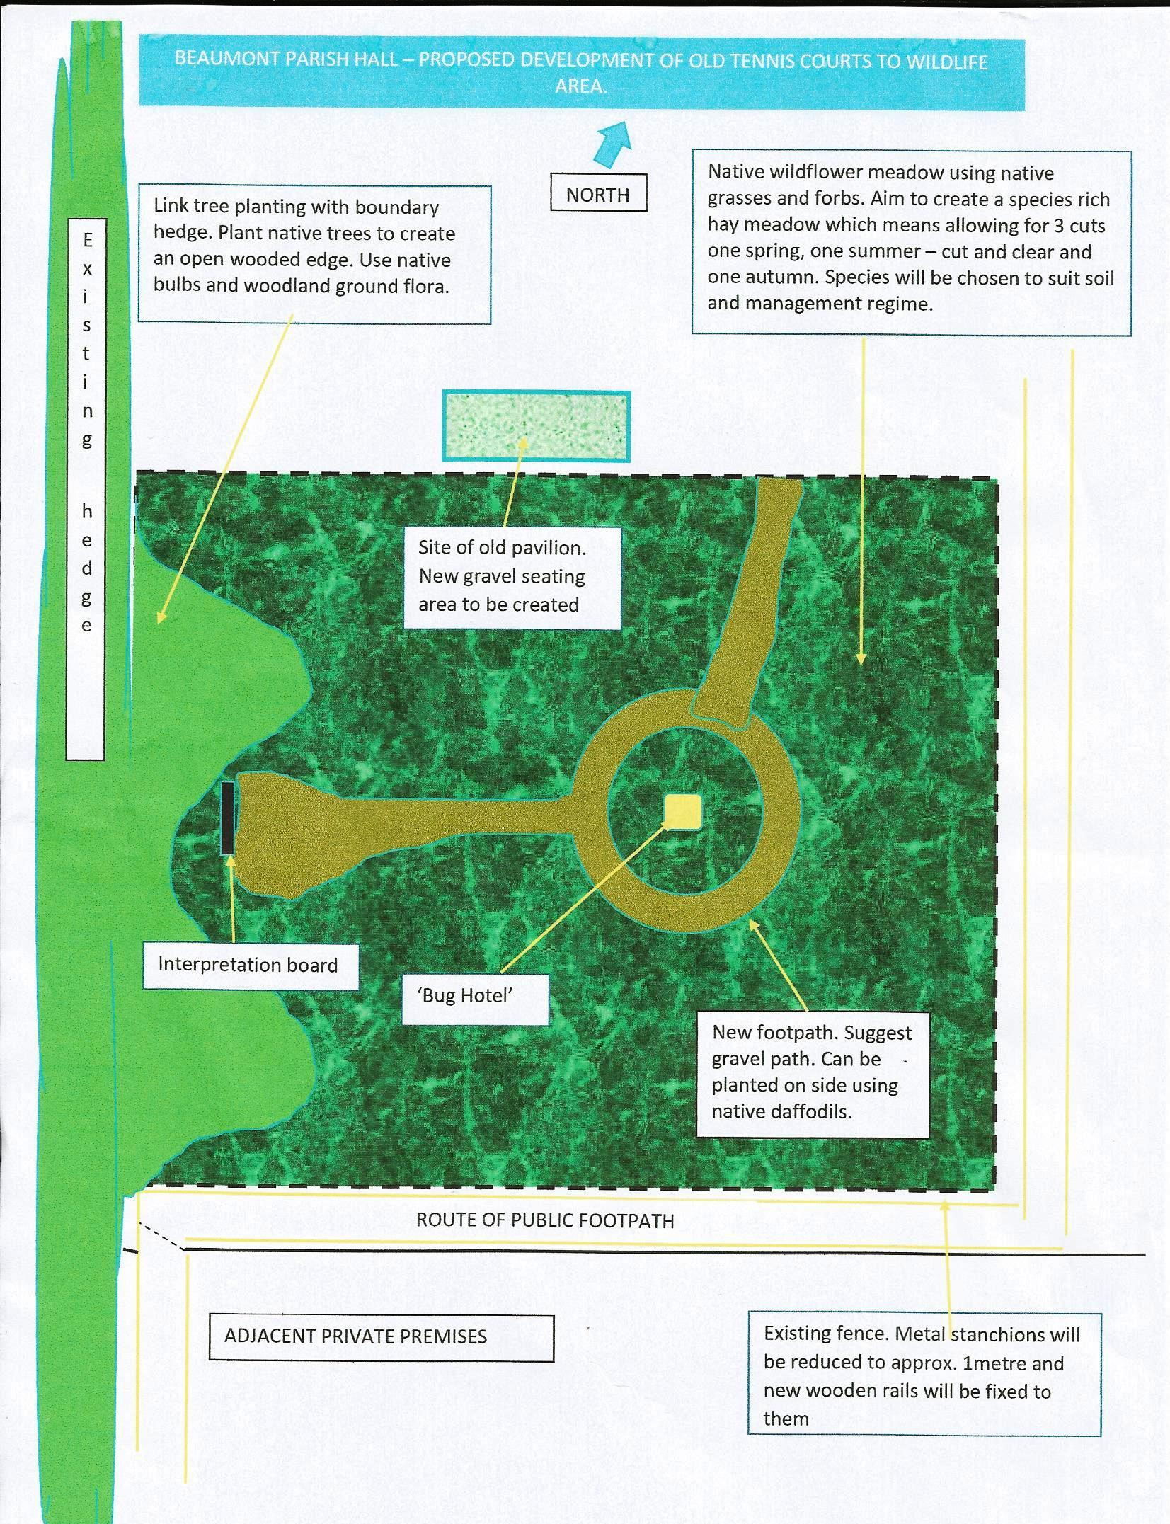

Drawing of the proposed layout of the wildlife site.

The committee has arranged Wildlife Area Community volunteer day on Saturday 16th September 2017 from 1pm onwards.
Do you want to increase your knowledge about our native wildflowers and help create the new wildlife area in Beaumont Parish Hall grounds? Following a short introduction, we will be sowing wildflower seeds and planting native plug plants. All ages and abilities are welcome. Tea and biscuits will be provided. Contact Malcolm on 576268 for further details or just turn up on the day.

Photographs of the work being undertaken

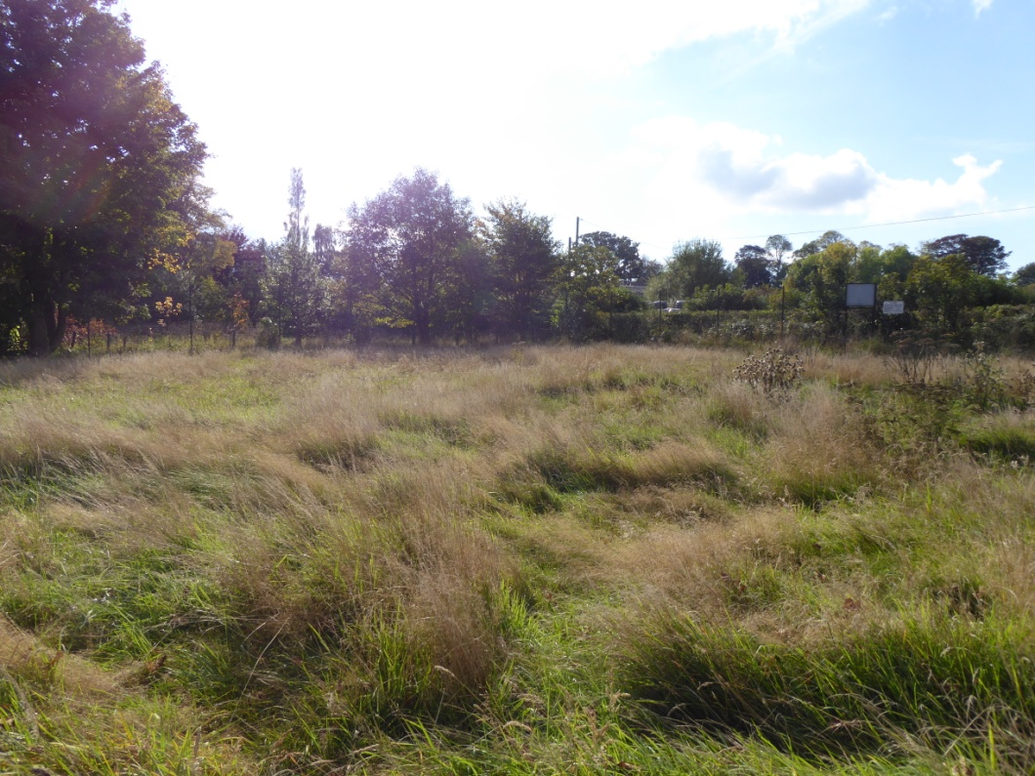
Tennis court area before work started

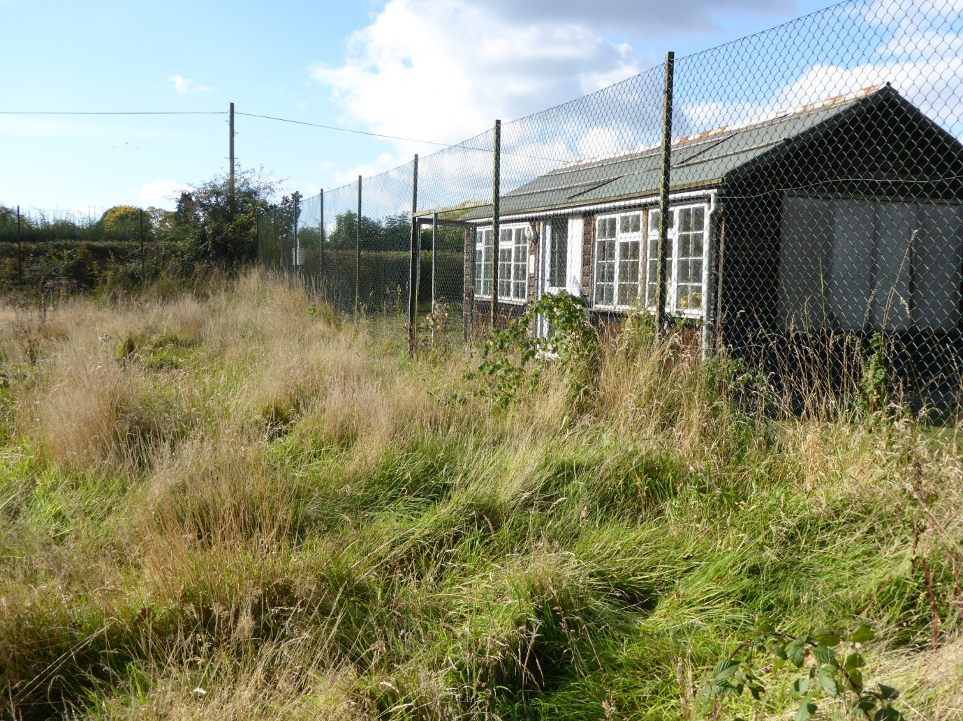
Pavilion from inside the disused tennis courts before its demolition

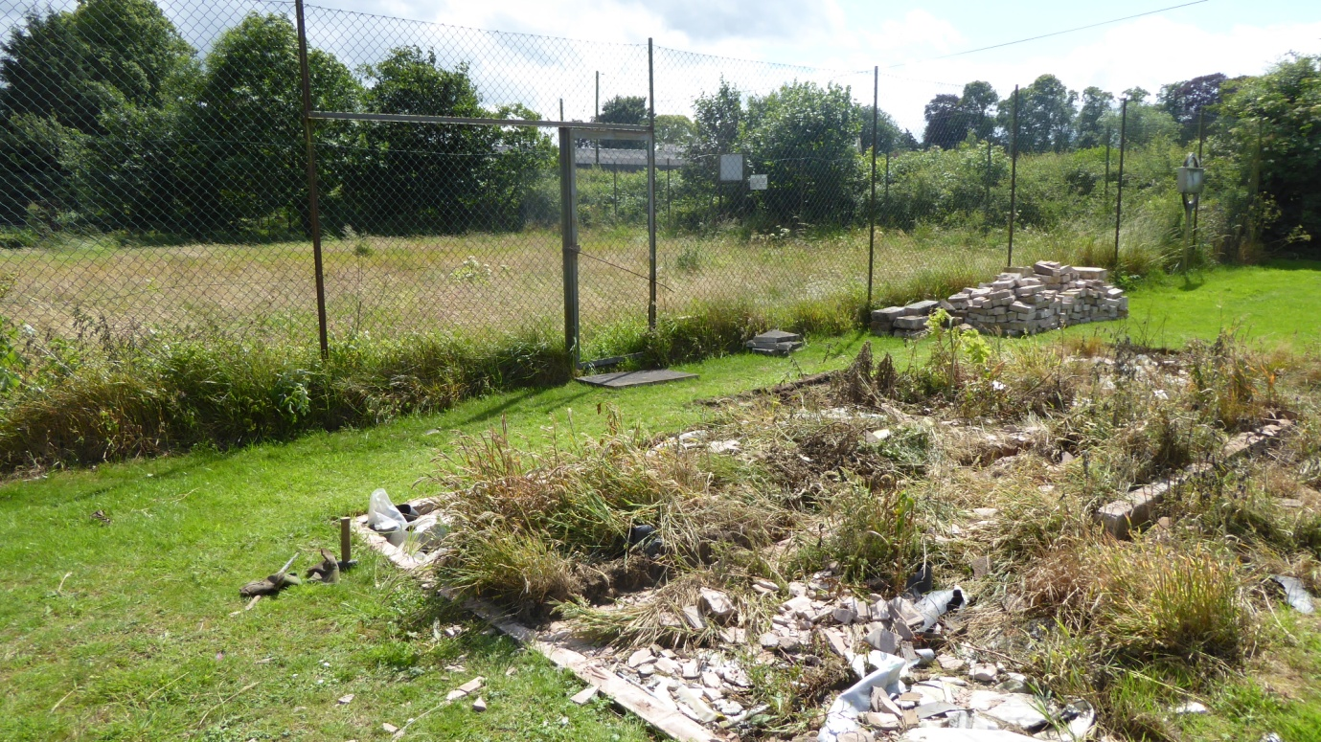
The foundations of the pavilion are removed (July 2017)

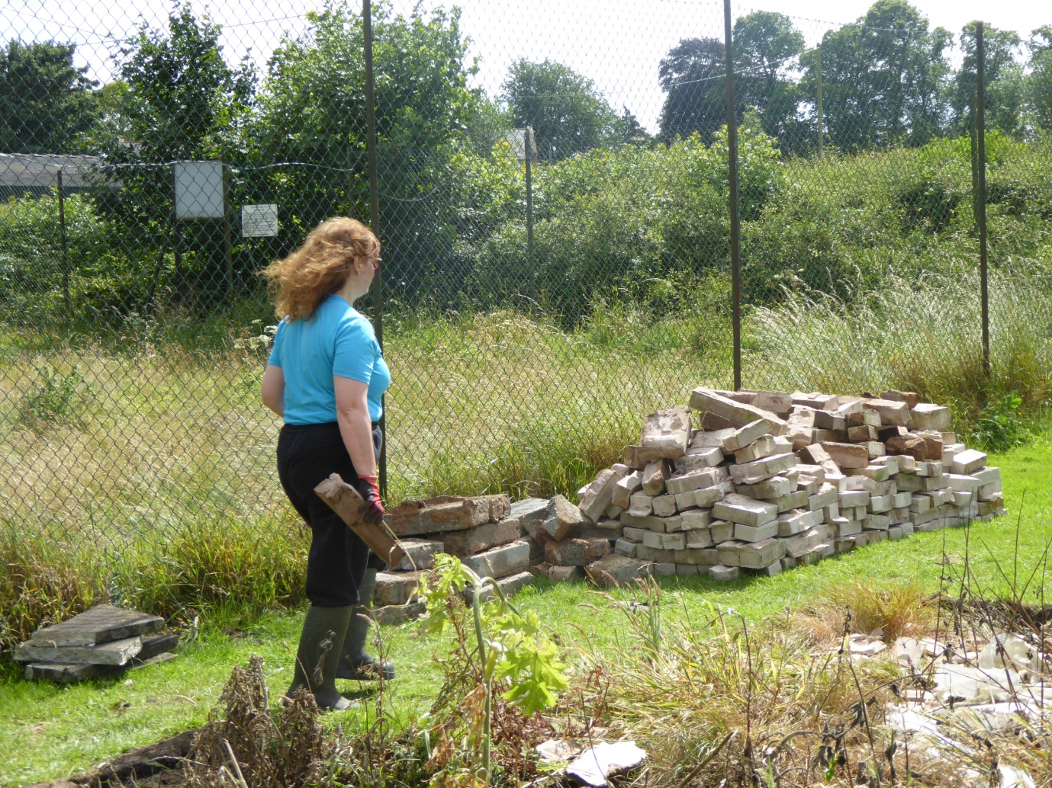
Removal of the pavilion foundations

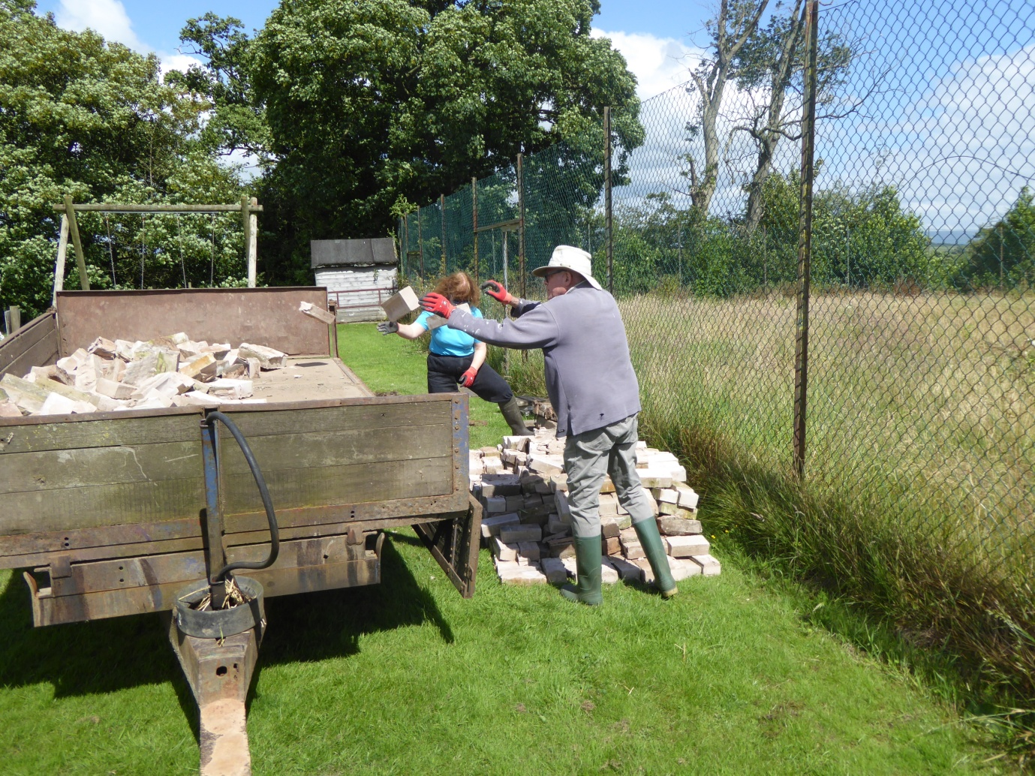
Loading of the foundations of the pavilion to a trailer (July 2017)

Project funded by Friends of the Lake District.
Seed and plants supplied by Cumbriawildflowers, Great Orton.

Local farmers help to remove the top layer of the wildlife area in preparation for seed sowing and planting of native plants.
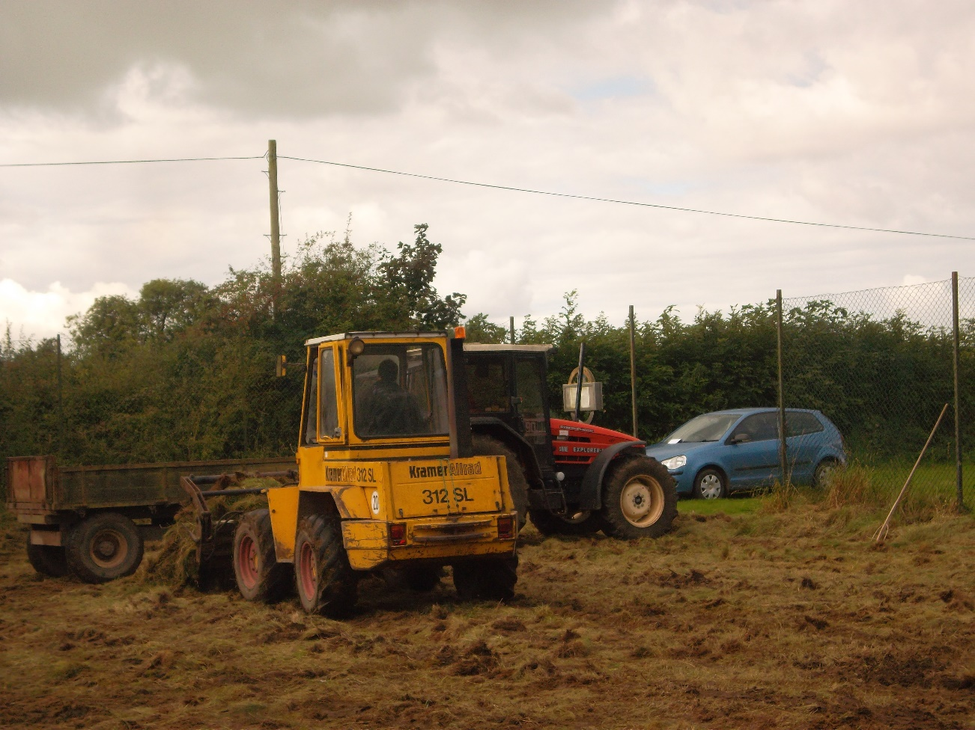

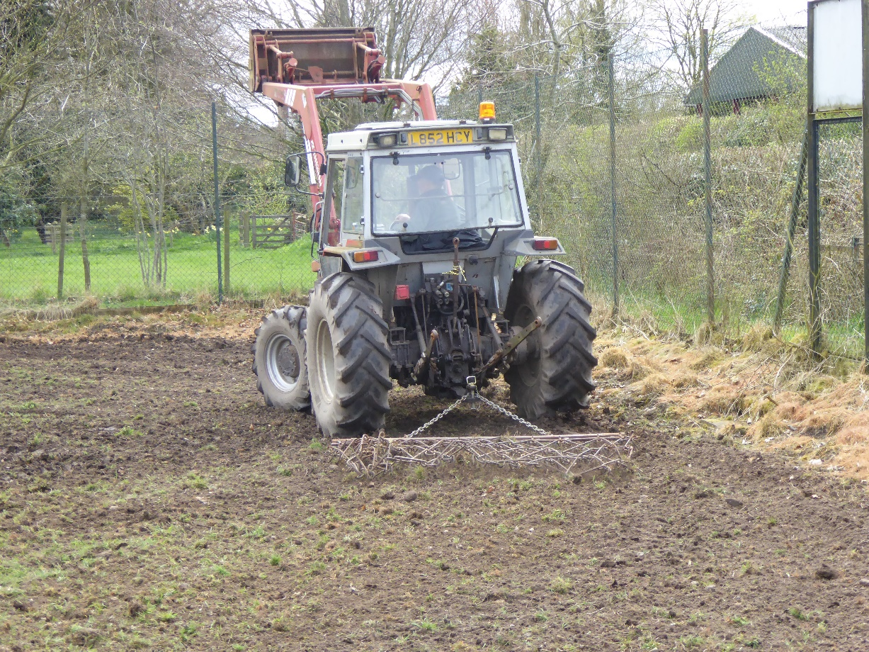

Sowing of native grasses local to the area with native seedlings by community volunteers.

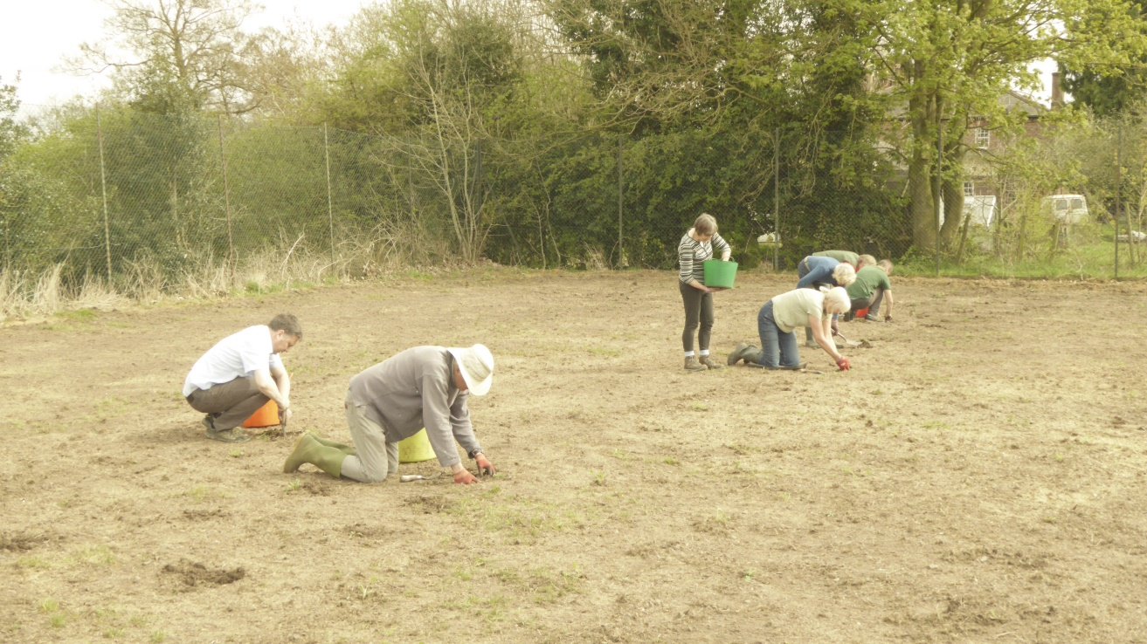

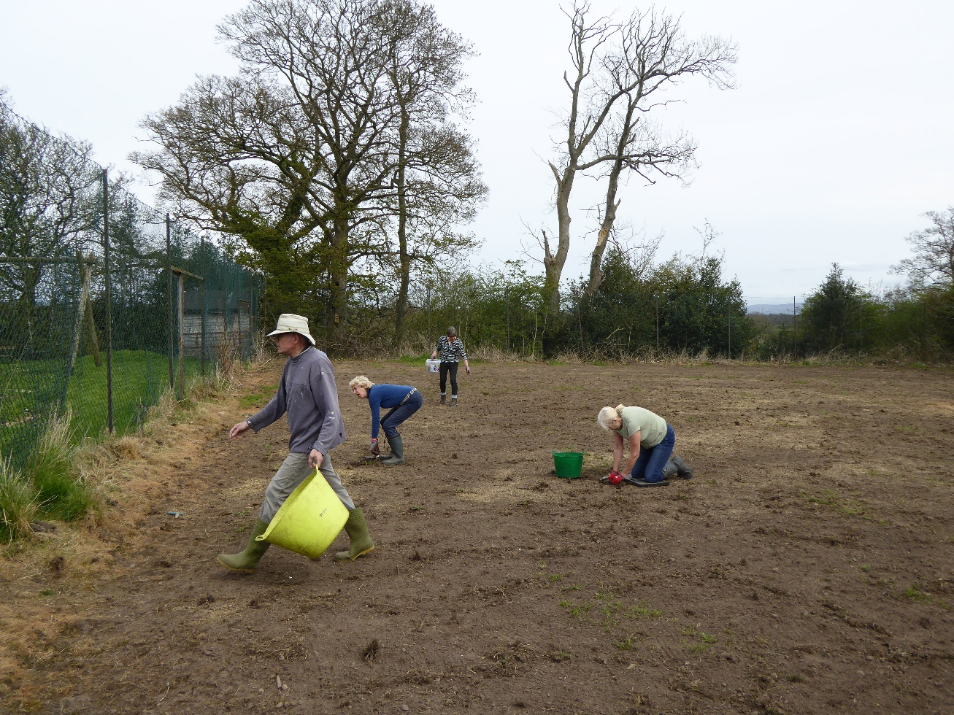

Some new photographs have been added showing how the wildlife area has developed this year, with quite a few different species of flower on show. This has been despite the drought, and the site will develop better over the next couple of years as more of the perennial plants come through. There is a pathway now cut through the area, so please feel free to go and have a look at it.

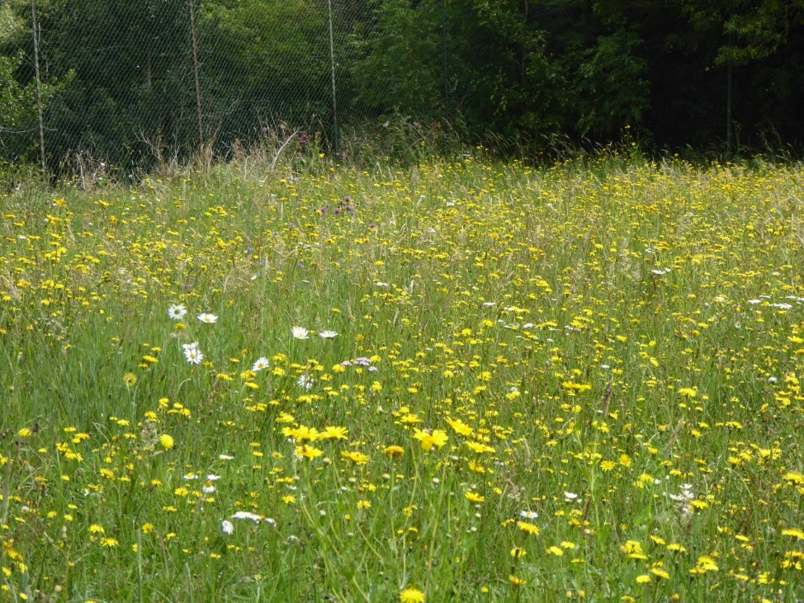

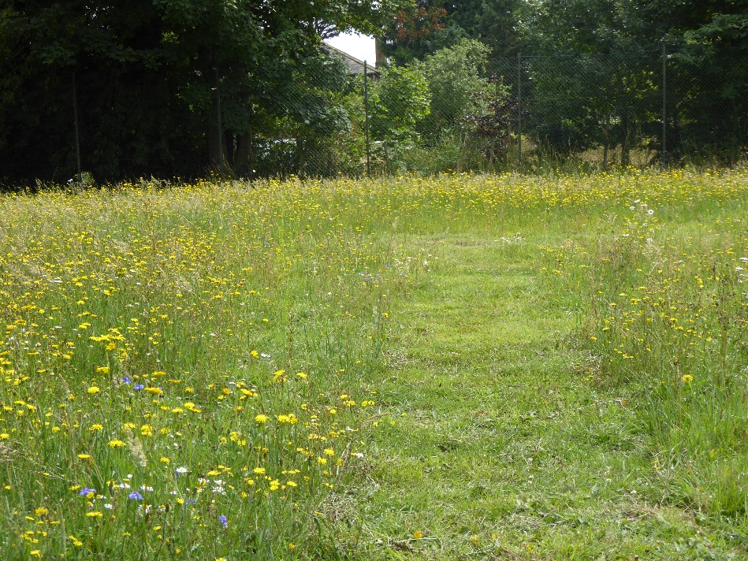
Wildlife area in August 2018

